**Core Java**

**Section 1: Introduction**

For developing Java program, we require JDK. JDK has runtime environment.

* JDK: Java Development Tool Kit: developments tools for compiling, debugging. + JRE.
* JRE: Java Runtime Environment: Java Class Library + JVM.
* JVM: Java Virtual Machine: This is actually executing the program.

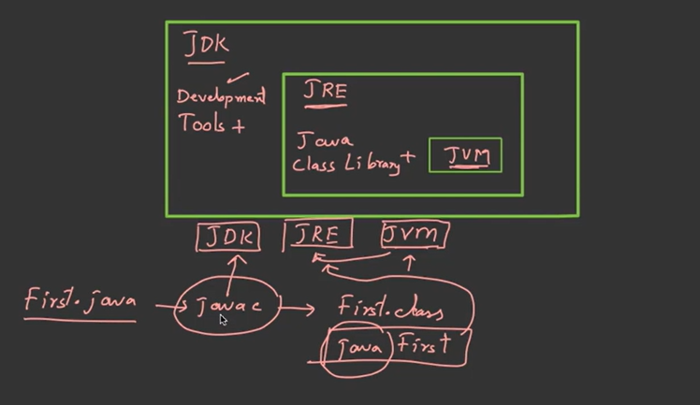

*🡪First.java—>javac(JAVA Compiler is* part of JDK*)🡪 (this will give us a file called)🡪 First.class  
🡪for compilation we use javac—is development tool.  
🡪for execution we use java—it will start runtime environment.*

***Definitions:***

* JVM (Java Virtual Machine): It is called a virtual machine because it doesn’t physically exist. It is a specification that provides a runtime environment in which Java bytecode can be executed. Loads code.   
   🡪Load code.

🡪Verifies code.

🡪Executes code.

🡪Provides runtime environment.

* JRE Java Runtime Environment: It is also written as Java RTE. It is a set of software tools which are used for developing Java applications. It is used to provide the runtime environment. It is the implementation of JVM. It physically exists. It contains a set of libraries + other files that JVM uses at runtime.
* JDK Java Development Kit is a software development environment which is used to develop Java applications. It physically exists. It contains JRE + development tools.

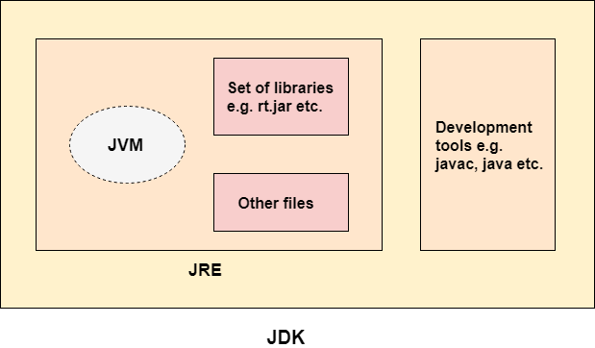

**Installing JDK**

1.Google: Oracle JDK Download JDK 17 LDS ( it’s a stable version) and Install.

2.Go to cmd and check java -version and the javac -version

3.If Javac doesn’t give you version then you have to set the path.

**Skeleton of Java Program**

First.java

*import java.lang.*;* 🡪 lang is package (libraries) lang is mandatory package.  
*class First 🡪 it should be same as file name.*

*{*

*public static void main(String args[])* 🡪 Main Method

*{*

*System.out.println(“Hello World”); 🡪* Print Statement

*}*

*}*

Run: CMD  
1. Run the command *javac First.java 🡪*  call java compiler 🡪 it will check java code if it is error free and then generate a bit code.

2. *First.class* is the bit code. Error free file. – this is the class name.

3.Run command *java First (* java and class name).

4. JVM is an interpreter it will convert bit code into machine code and it will execute the program.

***Entry Point of Java Program:  
public static void main(String args[])***  It’s a Signature , it should be present in the program.

JVM looks for the main method when it starts execution.  
***main()*** is a method which is entry point of java program.

***Public: (*Access Specifier*)*** It should be accessible. Because main method is inside the class so JVM should be able to see the main method to execute.

***Static: (Keyword)*** We cannot use the class without creating an object, so if you want to use the class without creating an object then you have to use ***static.***

***Java First 🡪 it will call First.main()🡪 it will create an object🡪 If you write static, it won’t create🡪 If you run without static then it will show error (not able to find class).***

***Void: (Return Type)*** It specifies that main method doesn’t return anything.

*As the main() terminate, java program also terminates. It doesn’t make any sense to get return from main. JVM Kya krega us return ka bcz program is over.*

***String arg[]***  It’s a Java command line arguments.

**Reading data from Keyboard**

***Scanner Class***: Present in ***java.util*** package.

Program:

*import java.lang.*;*

*import java.util.*;*

*class Keyboard*

*{*

*Public static void main(String args[])*

*{*

*Scanner s= new Scanner(System.in); 🡪* **class name, s is reference, Scanner is**

**constructor , System.in 🡪 object is associated with keyboard.**

*Int a,b,c;*

*System.out.printlin(“Enter 2 numbers:”); 🡪*

*a=s.nextInt(); 🡪* ***s is reference to scanner .nextInt will return the value.***

*nextInt read and interger and return to s i.e.. scanner.*

*B=s.nextInt();*

*c=a+b;*

*System.out.println(“Sum is” +c);*

*}*

*}*

***Definition****:*In Java, Scanner is a class in java.util package used for obtaining the input of the primitive types like int, double, etc. and strings.  
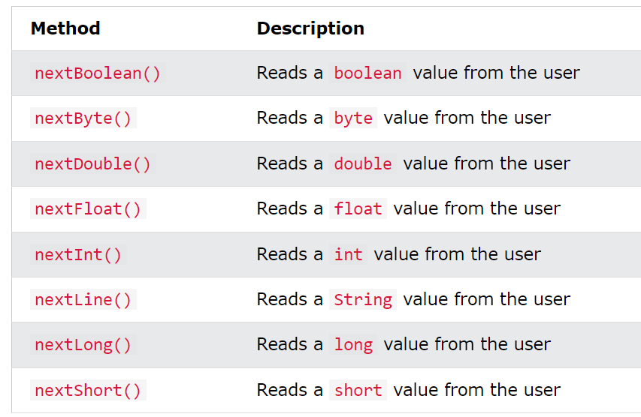

**Section 2: Data Types**

**Data Types:**When a program is running in a memory it should hold the data. Temporarily not permanently in the hard disk. So, we store the data in Variables. So, in Java we must first declare that variables. Variable should have some data type. So, we have some predefined data type for this.

Data types specify the different sizes and values that can be stored in the variable.   
There are two types of data types in Java:

1. **Primitive data types:** The basic data type is Java that is build in given in the compiler of Java.   
   Primitive data are single values with no special capabilities.   
   There are 8 primitive data types:

* boolean: stores value true or false
* byte: stores an 8-bit signed two’s complement integer
* char: stores a single 16-bit Unicode character
* short: stores a 16-bit signed two’s complement integer
* int: stores a 32-bit signed two’s complement integer
* long: stores a 64-bit two’s complement integer
* float: stores a single-precision 32-bit IEEE 754 floating-point
* double: stores a double-precision 64-bit IEEE 754 floating-point

Ranges:

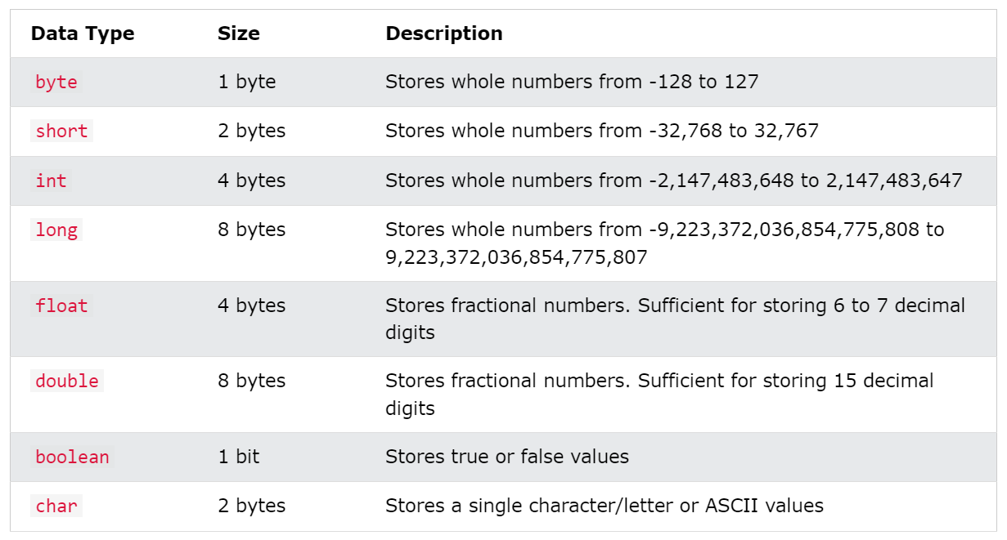

**Remark:** Java provide wrapper around primitive of data type. It provides class around primitive. Integer Class is the example.

1. **Non-primitive data types:** The non-primitive data types include [Classes](https://www.javatpoint.com/object-and-class-in-java), [Interfaces](https://www.javatpoint.com/interface-in-java), and [Arrays](https://www.javatpoint.com/array-in-java).  
   Reference Data types will contain a memory address of the variable’s values because it is not able to directly store the values in the memory. Types of Non-Primitive are mentioned below:

* Strings
* Array
* Class
* Object
* Interface

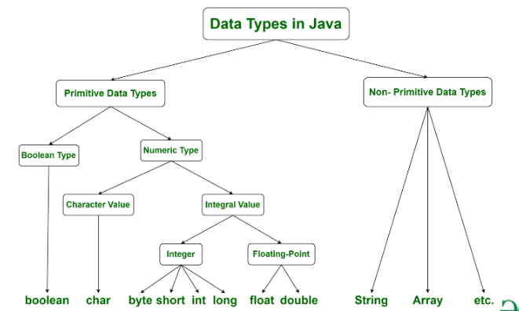

**Variables:**Variables are name given to data or variables are used for storing data. Variable must have data type.  
Variable must be declared before using it. When you Run the program, the variable occupied space according to their type and the values are stored in that memory.  
int i 🡪 Variable deceleration  
int i=5; 🡪 Variable Initialization

Data Types is selected depending upon the values or decimal point or character.

**Name of Variable:**

1. Case Sensitive  
    *int amount* and *int Amount* are two different variables   
    *int x and float X* are different but int x and float x are not allowed.
2. Contains Alphabets, Number, _ or $
3. Starts with Alphabets, _ or $ but not number.
4. Should not have keyword.
5. Should not be a class name, if class is also in use.
6. No limit on length of name
7. Follow camel case. 🡪 averageMarkOfClass

**Types of Variables:**

Instance variables and local variables are both types of variables in Java, but they have different scopes and lifetimes:

**Instance Variables:**

* Instance variables are declared within a class but outside of any method, constructor, or block.
* They are also known as member variables or fields.
* Each instance of the class (i.e., each object) has its own copy of instance variables.
* Instance variables are initialized when an object of the class is created and are accessible throughout the entire lifetime of the object.
* Instance variables are associated with objects and exist as long as the object exists.
* When we haven’t initialized the instance variables then the compiler initializes them with default values.

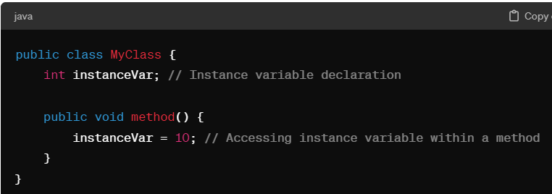

**Local Variables:**

* Local variables are declared within a method, constructor, or block and are only accessible within that scope.
* They are created when the method, constructor, or block is entered and destroyed when it exits.
* Local variables must be explicitly initialized before they are used, either by assigning a value or by reading from an input source.
* They do not have default values and must be initialized before use to avoid compilation errors.

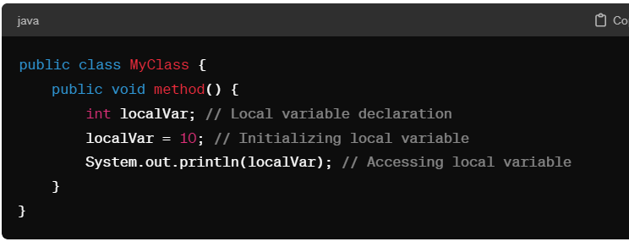

***Remarks: Local variables have higher priority than instance variables or class variables with the same name within their scope.***

***Literals***Constant values that can be assigned to the variable in called literals/constants. 25 is literal in int value=25.

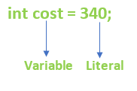

* Z=5*x+7*y 🡪 5 & 7 are literals. These are values without decimal so these are integer literals.
* area = 3.1425*radius* radius 🡪 3.1425 is double literals. Any value with decimal is double literal in Java.
* String str=”Java”🡪 Java is string literal🡪 Any value in double coot 🡪String Literal
* Char c=’A’🡪 Character Literal🡪 Any Value in single coot.

## **Types of Literals in Java**

There are the majorly **four** types of literals in Java:

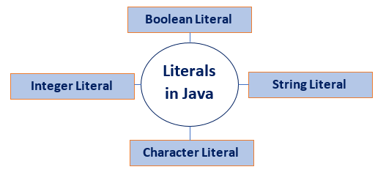

***Program:  
public class LiteralPrgm {***

***public static void main(String[] args) {***

***long l= 99999999999l;***

***//9999999 of type int is out of range,, the data type is long but literal is still integer as in java by default it integer so we added 'l' to make it long literal.***

***int l = 125L;// is also not possible --> Error--> Type mismatch: cannot convert from long to int.***

***System.out.println(l);***

***}***

***}***

|  |  |
| --- | --- |
| Byte | Int |
| Short | Int |
| Int | Int |
| Long | L or l |
| Float | F or f |
| Double | D or d |
| Char | ‘ ‘ |
| String | “ ” |
| Boolean | True/false |

**Section 3: Features and Architecture**

**Section 4: Operators and Expressions**

Operator in [Java](https://www.javatpoint.com/java-tutorial) is a symbol that is used to perform operations.

There are many types of operators in Java which are given below:

* Unary Operator,
* Arithmetic Operator,
* Shift Operator,
* Relational Operator,
* Bitwise Operator,
* Logical Operator,
* Ternary Operator and
* Assignment Operator.

**Arithmetic Operators:**

We can perform arithmetic operation on int, float, double, char but not Boolean.

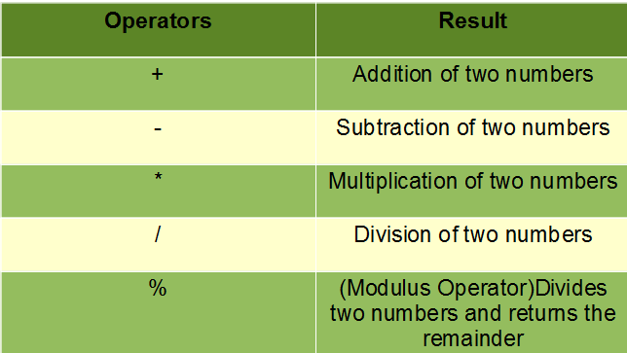

🡪 Modulus operation is applicable on decimal value also but the quotient should not be decimal.  
e.g.:

3.1)12.7(4   
 12.4  
---------------  
 0.3 🡪Result of modulus

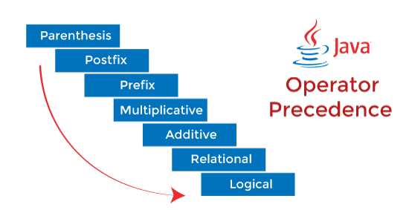

**Reading and Precedence of operators:**

* , / , % 🡪 Executed first

+ , - 🡪 Then this  
Precedence is from Left to Right. Means: Left me jo pahle ayaa  
If you want to do addition first the is parenthesis.

**Expression: A= 6 , B=10**

**A+B = 16 = 8** In Java if you write a+b/2 then answer is 11. So use Parentheses (a+b)/2=9 **2 2**

**Results of expressions with different data type.**

**Byte + Byte  
Short + Short  
Byte + Short = All are Integer 🡪 Internal process is called Coercion.  
Int + Int  
Short + Int   
If float is used so result will be float.  
Int + Float = Float 🡪 Internally Int will be converted into float and the calculated(Coercion)  
Float + Double = Double  
Long + Double = Double  
  
Program to Find Roots of quadratic equation.**

import java.util.*;

public class RootQuadtratic {

    public static void main(String[] args) {

        Scanner sc=new Scanner(System.in);

        int a, b,c;

        double r1,r2;

        System.out.println("Enter values of abc");

        a= sc.nextInt();

        b= sc.nextInt();

        c= sc.nextInt();

        r1=(-b+Math.sqrt(b*b-4*a*c))/(2*a);

        r2=(-b-Math.sqrt(b*b-4*a*c))/(2*a);

        System.out.println("Roots are"+r1+"   "+r2);

    }

}

**Increment/ Decrement Operator:**

Post++ and Post--  
++Pre and –pre  
***Let x= 5;***

Y= x++; 🡪 Y= 5 and X= 6 🡪 Assign the value of x to y the Increment x by 1.  
 (Use the value of x the increment.)

Y= ++x 🡪 Y=6 and x=6 🡪 Increase the value of x then assign it to y.

**Bitwise Operator**

|  |  |  |
| --- | --- | --- |
| **Operator** | **Name** | **Description** |
| & | AND | Sets each bit to 1 if both bits are 1 |
| | | OR | Sets each bit to 1 if one of two bits is 1 |
| ^ | XOR | Sets each bit to 1 if only one of two bits is 1 |
| ~ | NOT | Inverts all the bits |
| << | Zero fill left shift | Shifts left by pushing zeros in from the right and let the leftmost bits fall off |
| >> | Signed right shift | Shifts right by pushing copies of the leftmost bit in from the left, and let the rightmost bits fall off |
| >>> | Zero fill right shift | Shifts right by pushing zeros in from the left, and let the rightmost bits fall off |

**Section 5: String Class and Printing**

**Printing**Java is providing a building class call ***system*** and this have an object called ***out***.  
Out is attached to console.  
This object is have different methods:  
1. System.out.print() 🡪 Take all data types as parameter, object, expression but single   
 parameter.  
2. System.out.println() 🡪 Take all data types as parameter. Appends new line.  
3. System.out.printf() 🡪   
4. System.out.format() 🡪

**Eg:**

**X=10, Y=20;**

**System.out.print(x+y+ “sum is”)** 🡪*30 sum is* **System.out.print(“sum is”+x+y)** 🡪 *sum is 1020*

**System.out.print(“Sum of ”+ x+”and ”+y+”is”+(x+y))** 🡪 *Sum of 10 and 20 is 30* .

**String In Java:**String is a collection of characters. String is a built-in class in java. But it is also used as data type.  
*String str = “ Java Program”; JP is a literal  
str is reference to the object(java program).str will hold an reference to object.  
Note- Java Create a pool of string literals.***Program:**

public class StringPractice {

    public static void main(String[] args) {

        String str1="Java Program"; //created in string pool

        String str2=new String("JAVA"); // created in heap.

        char c[]={'H','e','l'};

        String str4= new String("Java Program");

        String str5="Java Program";

        String str3=new String(c);

        System.out.println(str2);

        System.out.println(str1);

        System.out.println(str3);

        System.out.println(str1==str4);

        System.out.println(str1==str5);

    }

}

*Output:  
JAVA*

*Java Program*

*Hel*

*False // because it match with the heap.*

*true // because it matches in the pool of string.*

**String Class Methods:**

*1.Int length 🡪 length of string 🡪int l = str.length();*

*2.String toLowerCase()*

*3.String toUpperCase()  
Note: String will change the case. But it will not change the same string object. String are immutable. They cannot be modified. It will take that string create a new string and return a new string so we have to take new string reference to store it. And also this new string will be created in heap.  
 e.g.: String str=”Java”;  
 String str2=str.toUpperCase;  
4.String trim() 🡪 Removes the spaces. New object with no space will be created.  
5.String substring(int begin index)-> Return a part of string.  
 e.g.: String str=”welcome”;  
 String str2=str.substring(3);  
 Result- Come  
6. String substring(int begin, int end)🡪 end is it will stop there i.e. end-1 will be printed.  
 e.g.: String str2=str.substring(3,6);  
 Result- Com  
7.String replace(char old, char new);  
 e.g.: Str= str.replace(e,k) 🡪new string will be created.  
8.boolean startsWith(String s)  
9.boolean endsWith(String s)🡪 str.endsWith(“.com”)  
10.str.charAt(int index)  
11.Int indexOf(String s)🡪 str.indexOf(“A”)  
12. Int lastIndexOf(String s)🡪 search starts from right side  
13. Boolean equals()🡪 checks exactly same or not. strs.equals(str2)🡪 t or f  
 Note: new keywords ke sath wala true ayega. Bcz letter compare ho re.  
14.Boolean equalsIgnoreCase(String s)🡪Ignore the result.  
15.int compareTo(String s)🡪 Compare two string in dictionary order.  
 e.g: str1=java, str2=pythn  
 str1.comparteTo(str2)🡪 return -x🡪str1 pahle aya dict me. X is the difference between ascii value.  
Phele jo likha hai wo dusre se bada hoga toh minus me hoga.  
 str2.comparteTo(str1)🡪 return x🡪str1 pahle aya dict me. Give =0 if equal.  
 e.g.: str1=JAVA, str2=java  
 str1.comparteTo(str2)🡪 return -1🡪Bada java pahle ata hai  
16.String concat(string) 🡪 combine two string. Str1.concat(str2)  
17.String ValueOf*

**Regular Expression:**In Java, Regular Expressions or Regex (in short) in Java is an API for defining String patterns that can be used for searching, manipulating, and editing a string in Java.   
Email validation and passwords are a few areas of strings where Regex is widely used to define the constraints.  
Regular Expressions in Java are provided under *java.util.regex* package.  
Regular Expression are used for defining patterns for strings.  
Regex in Java provides 3 classes and 1 interface:  
1. Matcher Class  
2. Pattern Class  
3. PatternSyntaxException Class  
4. MatchResult Interface  
  
**1. Matchers Class:**Used to perform match operations for an input string in Java.  
Matching Symbols:  
**Regex Character Classes**

|  |  |
| --- | --- |
| **Regular Expression** | **Description** |
| . | Any Character |
| [abc] | Exactly given letters |
| [abc][vz] | Either first or second set |
| [^abc] | Except abc |
| [a-z1-7] | a-z or 1—7 |
| A|B | A or B |
| XZ | Exactly XZ |
| [a-z && p-y] | All elements in these two range. |
| [a-z && [^bc]] | a-z except bc. |
| [a-z &&[^m-p]] | A to z with except range m to p. |

public class RegularExpressionPractice {

    public static void main(String[] args) {

        String str1="kds";

        String str2="s";

        System.out.println(str1.matches(".")); // false -->just a single symbol.

        System.out.println(str2.matches("."));//true

        System.out.println("---Next Case---");

        String str3="ab";

        System.out.println(str3.matches("[abc]")); //fasle--> takes only on

character.

        String str4="pq";

        System.out.println(str4.matches("[abc]")); //fasle--> any one of abc

should be there.

        String str5="a";

        System.out.println(str5.matches("[abc]")); //true

        String strabc="abc";

        System.out.println("abc"+strabc.matches("[abc]")); //false--> anyone

        String str="ab";

        System.out.println(str.matches("[^abc]")); //false --> other than abc

will work but only one chara

        String stra="a";

        System.out.println(stra.matches("[abc]")); //true --> other than abc will

work but only one character

        String str6="a";

        System.out.println(str6.matches("[a-z0-9]")); //true

        String str7="a8";

        System.out.println(str7.matches("[a-z0-9]")); //false --> any one char

should be there.

        String str8="a8";

        System.out.println(str8.matches("[a-z][0-9]")); //True --> now 2 can be present.

        String str9="a";

        System.out.println(str9.matches("a|b"));// True --> aorb.

        String str10="abc";

        System.out.println(str10.matches("abc"));//true--> exactly same in"""

    }

}

**Meta Character Class**we have to use \\ bcz \ is scape sequence like \n \d.

|  |  |
| --- | --- |
| **Regular Expression** | **Description** |
| \d | Only one single digit. |
| \D | Not Digits –single |
| \s | Space |
| \S | Not Space |
| \w | Alphabet or Digit |
| \W | Neither alphabet nor digit |

**Quantifiers**We can attach it with characters and meta characters to get the desired result.

|  |  |
| --- | --- |
| **Regular Exp** | Description |
| * | 0 or more |
| + | One or more |
| ? | 0 or 1 time |
| {m} | M times |
| {m,n} | Between m to n times |
| {n,} | n or more than n times |

E.g.:

|  |  |
| --- | --- |
| X? | X appears once |
| X+ | X appears one or more |
| X* | X appears zero or not once. |
| X{n} | X appears n times or more than n |
| X{n,m} | X appears greater than equal to n times and less than m times. |

**Program:**public class MetaCharacterRegularExpression {

    public static void main(String[] args) {

        String str1="kds";

        String str2="s";

        System.out.println(str1.matches("\\w")); // false -->just a single

symbol.

        System.out.println(str2.matches("\\w"));//true

        String str3="ab";

        System.out.println(str3.matches("\\W")); //fasle--> takes only on

character.

        String str4="%";

        System.out.println(str4.matches("\\W")); //True--> other than abc 0-9

should be there.

        String str5="%$";

        System.out.println(str5.matches("\\W")); //FLASE--> 2 input

        String str6="0";

        System.out.println(str6.matches("\\d"));// True--> takes digit

        String str7="x";

        System.out.println(str7.matches("x?"));// true-- x appears once

        String str8="xxxx";

        System.out.println(str8.matches("x+"));// true x appease once or more

than once.

        String str9="xxx";

        System.out.println(str9.matches("x{3}"));// true x appears 3 times

    }

}

**Section 7: Conditional Statements**

Conditional statements mainly use Relational operators.

|  |  |  |  |
| --- | --- | --- | --- |
| Relational Operator | Description | e.g. a=5,b=10 | Boolean Result |
| < | Less Than | a<b | True |
| <= | Less Than Equals | a<=b | False |
| > | Greater Than | b>a | True |
| >= | Greater Than Equals | b>=a | True |
| == | Equals | a==b | False |
| != | Not equal | a!=b | Trues |

**Logical Operators:**

Two or more conditionals’ statements can be combined using logical operator.  
**AND-**Both should be true  
**OR-** Either statement true  
**NOT-** just reverse the results **Let a=5,b=10,c=15.**

|  |  |  |  |  |
| --- | --- | --- | --- | --- |
| **A** | **B** | **A &&B** | **A||B** | **!A** |
| **True** | **True** | **True** | **True** | **False** |
| **True** | **False** | **False** | **True** | **False** |
| **False** | **True** | **False** | **True** | **True** |
| **False** | **False** | **False** | **False** | **True** |

***Conditionls statements is the set of statements which are executed based on value of statements.****if(condition)  
{  
If true this will be executed  
}  
else  
{  
It false this will be executed  
}*

## **Java Switch Statements**

Instead of writing many if. Else statements, you can use the switch statement.  
The switch statement selects one of many code blocks to be executed.

This is how it works:

* The switch expression is evaluated once.
* The value of the expression is compared with the values of each case.
* If there is a match, the associated block of code is executed.
* The break and default keywords are optional

## **The break Keyword**: When Java reaches a break keyword, it breaks out of the switch block. This will stop the execution of more code and case testing inside the block.

## **The default Keyword:** The default keyword specifies some code to run if there is no case match.

**Section 8: Loops In Java**

Loops are repeating the set of statements. Loops can execute a block of code as long as a specified condition is reached.  
There are four types of loops in java:  
1. While loop  
2. Do while loop  
3. For loop  
4. For each loop  
**While Loop:**The while loop loops through a block of code as long as a specified condition is true.  
while(condition)  
{  
 process  
} while word means as long as the condition.  
Condition: Mix sugar in coffee till it get sweeten.

**The Do/While Loop**The do/while loop is a variant of the while loop. This loop will execute the code block once, before checking if the condition is true, then it will repeat the loop as long as the condition is true.

Do  
{  
 process  
}while(i<n);

**For Loop:**When you know exactly how many times you want to loop through a block of code, use the for loop instead of a while loop. For loop is the counter control loop.  
For means for this many times.  
Condition: Mix 5 spoon of sugar.  
for(initialization; condition; updation)  
{  
 process  
}

1.counter initialization is done  
2.condition is done  
3.if condition true, body is executed  
4.Updation of counter  
5.condition is check till its false

**Section: 8: Array**

Array is the collection similar data elements.  
X=[8,9,3,4,5] 🡪 Array  
X=[x0 ,x1, x2..]  
X=[2,3,4,k,3,4,k] 🡪not an array

Int A[] = new int[5]

A[]- reference of  
int[5]- object🡪 every array in java is an object.  
new🡪 every array in java is created in heap.  
for creating an array either we can give the size or we can given the element  
int A[]={2,3,4,5}

**Section 9: Methods**

Methods are the member of the classes which provides functionality for the objects.  
Like in string class there was a method for length(), substring(), Index of().  
Simply methods are mechanism or functionality or procedure.  
Its same as functions but we called it as method because of object oriented methodology.  
  
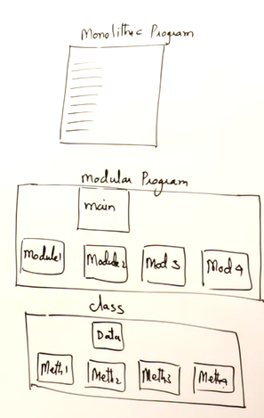

Implementation or body of a methods:  
*returnType methodName(parameter list) 🡪 called as signature or header of method   
{  
procedure….  
………………..  
}  
e.g.:*

*Maximum of 2 number  
int max(int x, int y)  
{  
 if(x>y)  
 return x;  
}  
 else  
 return y;  
}  
  
Note: Static method can call only static methods.*

public class MethodExp {// max of two number

    static int max(int x, int y)   // formal parameters

    {

        if(x>y)

        return x;

        else

        return y;

    }

    public static void main(String[] args) {

        int a=10,b=15,c; // actual parameters

        c=max(a,b);

        System.out.println(c);

    }

}

Note: If I want to remove static, we have to create an object of the method.  
Either you make the method as static or you create an object of that method.

public class MethodExp {// max of two number

     int max(int x, int y)   // formal parameters

    {

        if(x>y)

        return x;

        else

        return y;

    }

    public static void main(String[] args) {

        int a=10,b=15; // actual parameters

        MethodExp mp= new MethodExp(); // object of method

        System.out.println(mp.max(a,b));

    }

}

**Explanation:  
The line MethodExp mp = new MethodExp(); Java is creating a new object of the class MethodExp and assigning it to a variable mp. Let's break down what each part of this line does:**

* **MethodExp: This is the name of the class you are instantiating. In Java, classes are used as blueprints for creating objects. Here, MethodExp is assumed to be the name of a class.**
* **new: The new keyword is used to create a new instance of a class. It allocates memory for the new object and initializes its state.**
* **MethodExp(): This is the constructor of the class MethodExp. Constructors are special methods used for initializing objects. When you use the new keyword to create an object, the constructor of that class is called to initialize the object.**
* **mp: This is the name of the variable that will hold the reference to the newly created object. In this case, mp is of type MethodExp, which means it can hold references to objects of the MethodExp class.**

**Return type of a method:**Any data type can be return type. If no return then use void.  
Return type can be an object also.  
like String username(string email) even it can be array object as it is create in heap.  
In Java, when you pass primitive data type then the actual parameter is not change but when you pass an object i.e. non primitive i.e. string array.--> the actual parameter will be changed.  
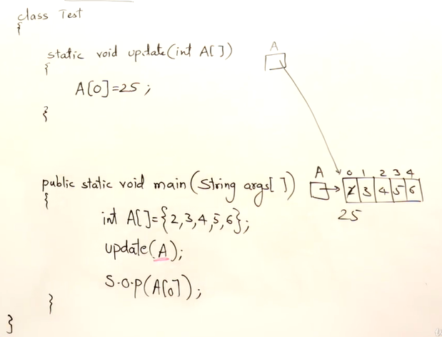 A[0]= 25 now.

**Method Overloading:**Java allows methods with same name. Method overloading means writing more than one method with same name. But some difference must be there. This difference is should be there in parameter list. Either the data type of parameter should be different or the number of parameter should be different. Then java will read them as different methods.  
  
int max(int x, int y) 🡪 this will be called max(5,10)  
{……}  
float max(float x, float y ) 🡪this will be called max(5f,6f)  
{………}  
int max(int x, int y, int z) 🡪 max(8,2,3)  
{………}  
  
**Variable Arguments:**

**Show();  
Show(10,20);  
Show(10,20,30);  
Show (10,20,30,…);**when we have so many arguments then we have to write method for each argument using method overloading. So we have a concept of variable arguments. Consider all arguments data type must be same.  
we will do it as: ***void show(int …x)  
{….}***

**Recursion**

In Java, Recursion is a process in which a function calls itself directly or indirectly is called recursion and the corresponding function is called a recursive function.

**Section 11: Object Oriented Programming**

1. Abstraction
2. Encapsulation
3. Inheritance
4. Polymorphism

**1.Abstraction:** Hiding internal details and showing only required details.  
e.g.: to operate Tv you don’t need to go throughout the internal circuit you just need buttons.  
Abstract means we don’t know what’s inside.

**2.Encapsulation:** Everything is inside a capsule. Encapsulation mean in a box.

**3.Inheritance:** Reusing the code. **e.g.:** tv is tv are same but model is changed with new features.  
iPhone, Redmi , Samsung is inheriting from mobile.

Specialization: If you already have something and you are adding some new feature and coming with something new. Inheritance is specialization.  
e.g.: LCD is inherited from TFT.

Generalization: If you have few thing with same property you can group them and when you are referring you can use that generalized word.  
student Studying Java are Java students. Java student is a general terms

**4.Polymorphism:** Many forms. generalization is polymorphism.  
e.g.: car have multiple type Toyota, Hundai, Suzuki.  
when you learn car driving you don’t learn Toyota or hundai car driving. You just learn driving and you can drive any car. You have many forms.

**Classes and Object**

As per object-oriented programming you say that anything in the world is an objects.  
***Object = Thing  
Object is defined in term of properties and behavior.***eg: TV(OBJECT) Properties: Color of TV, weight and height, material type used, brand name.  
 Behavior: switch on-Off, Change brightness, change channel.  
Behavior will affect the properties.  
To create an object you must define a design first.  
To build a house you have to design a blueprint.  
***That design is a class.***From a same design you can make many houses.  
So, from a single class you can make any number of object.  
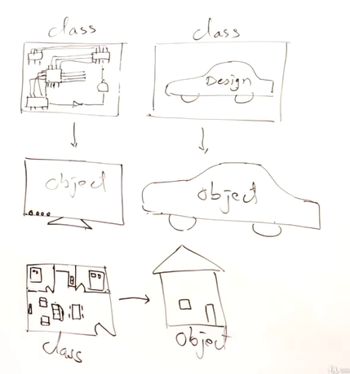  
  
Class Television{ 🡪 Television is defined in term of properties and behavior.

Private int channel; 🡪Properties  
Private int volume; 🡪 Behavior  
Public void changeChannel(); 🡪 Method()🡪 Method is nothing but operations.  
Public void changeVolume(); 🡪 Methods()  
}

Class Test  
{ public static void main()  
Television t= new Television() 🡪 Creating an object

}

**Data Hiding:**

Data hiding in Java is a concept that refers to the practice of restricting access to certain variables and methods within a class. It is achieved by using access modifiers to control the visibility of class members.

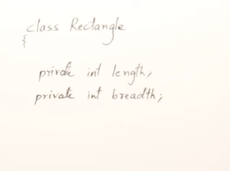

If you make the members as private. Then you can’t access them.

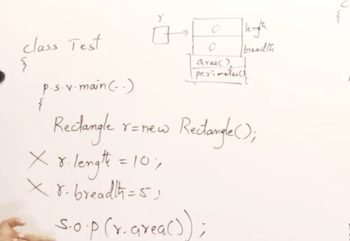

To access the data, we have to provide the method.  
we have to write the **property method** to read the data and write the data.

Using getter and setter.

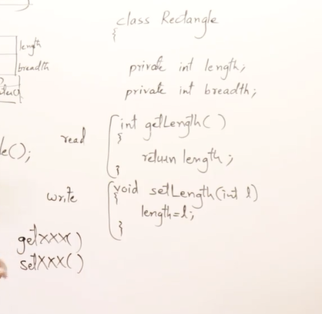

We can use setter method for validations.

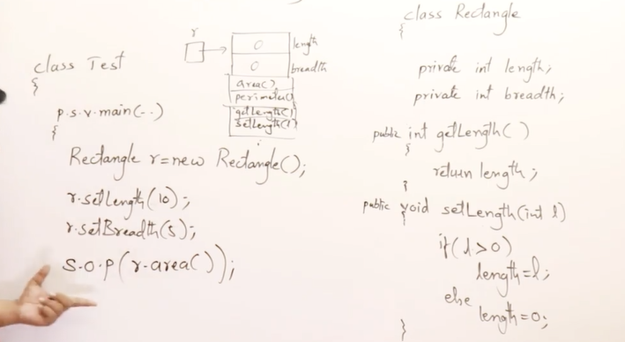

Getter- getlength- it will give you the value of length🡪 reading the value.  
Setter-setlength- it will set the value of length🡪 write the value. 🡪 it is void as it don’t have to return anything but they have to take parameter and assign those parameter to **property.**

**Types of Property**

**1.Read and Writeable:** When bot get and get method is present.

Class student{

Private int m1;

Getm1()🡪 reading the marks.

Setm1()🡪 writing the marks.

**2.Read Only:** Get method

Class student{

Private int roll; 🡪 roll no is fixed once.

Getroll();

**3.Write Only:** only writing i.e.. only set method.

It is exceptional. Some time one program will read the value and other will write the value.

Example: Producer will have set method only, and consumer will just read the value.

**Constructors:  
Need of Constructor:**

When you say **new** object is created in the heap with the default value zero.

Class Test{

Psvm(…){

Rectangle r= new Rectangle(); 🡪 when we say new the object is create with zero value.

r.setlength=10; 🡪 later we set the value as 10.

r.setbreadth=5;

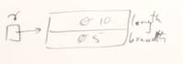

}

But I want to mention the length and breadth of rectangle at the time of creation means while construction of the object rectangle.  
Rectangle r=new Rectangle(10,5);

Note:

* Whenever an object is called a constructor is created by default.
* Every class in java has a default constructor. It created by compiler.
* If you want to use your you have to create.
* Constructor is a method of a class which will have same name as class.
* Constructor will be called automatically while creating an object.
* Constructor will not have any return type. Don’t even write void.
* Constructor as usually public but can be private.

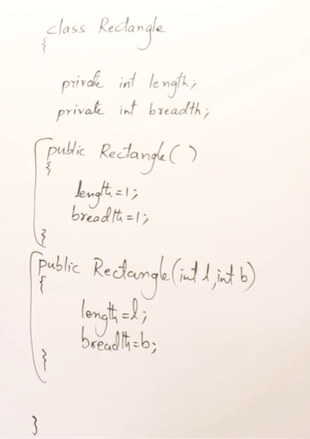 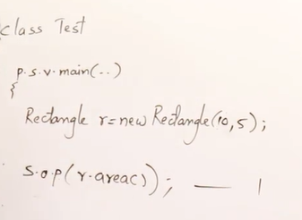

**Types of Constructors:**

**1.Non-Parameterized:** which doesn’t take any parameters.

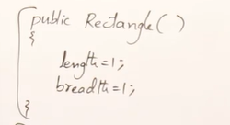

If it’s a non-parameterized constructors it will be the replacement of default constructor.

**2.Parameterized:** Which have parameters.

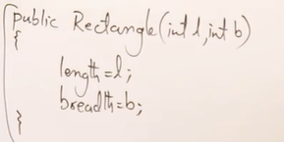

Constructors can be overloaded. You can write as many constructors as you need it.

**Flow of a Program in Java:**

public class Dog {

// Instance variables

private String name;

private int age;

// Constructor

public Dog(String name, int age) {

this.name = name;

this.age = age;

}

// Method to bark

public void bark() {

System.out.println(name + " says: Woof!");

}

// Method to display information about the dog

public void displayInfo() {

System.out.println("Name: " + name);

System.out.println("Age: " + age + " years");

}

public static void main(String[] args) {

// Creating objects of the Dog class

Dog dog1 = new Dog("Buddy", 3);

Dog dog2 = new Dog("Max", 5);

// Calling methods on objects

dog1.bark(); // Output: Buddy says: Woof!

dog2.bark(); // Output: Max says: Woof!

// Displaying information about dogs

dog1.displayInfo();

/*

Output:

Name: Buddy

Age: 3 years

*/

dog2.displayInfo();

/*

Output:

Name: Max

Age: 5 years

*/

}

}

1. Class Definition: We define a class named `Dog` with two instance variables: `name` (String) and `age` (int).

2. Constructor: We have a constructor `Dog(String name, int age)` that initializes the `name` and `age` of

a `Dog` object when it is created.

3. Methods:

* `bark ()`: This method prints out a message indicating the dog's name followed by "says: Woof!".
* `displayInfo()`: This method displays the name and age of the dog.

4. Main Method: We start executing from the `main()` method.

* Two `Dog` objects, `dog1` and `dog2`, are created with different names and ages using the `new` keyword and the `Dog` constructor.
* We call the `bark()` method on each `Dog` object (`dog1` and `dog2`), causing them to bark.
* We call the `displayInfo()` method on each `Dog` object to display their information.

5. Execution Output: After calling methods on `dog1` and `dog2`, the respective output messages are printed to the console, showing the names, barks, and information of each dog.

6. End of Program: Once all statements in the `main()` method are executed, the program ends.

In summary, the flow of the code involves creating `Dog` objects, calling methods on those objects, and displaying output accordingly. Each method call executes its corresponding code block within the `Dog` class, demonstrating the behavior of the `Dog` objects.

**Constructor:**

A constructor in Java is a special type of method that is automatically called when an object of a class is created. Its primary purpose is to initialize the newly created object. Constructors have the same name as the class and do not have a return type, not even void.

Here are some key points about constructors:

* Initialization: Constructors initialize the newly created object by assigning initial values to its instance variables or performing any other necessary setup tasks.
* Name and Signature: Constructors have the same name as the class they belong to. They can have parameters, allowing initialization with different values.
* Implicit Invocation: Constructors are invoked implicitly whenever a new instance of a class is created using the new keyword.
* Default Constructor: If no constructor is explicitly defined in a class, Java provides a default constructor with no parameters. This default constructor initializes instance variables with default values (e.g., numeric variables to 0, object references to null).
* Overloading: Like other methods, constructors can be overloaded, meaning a class can have multiple constructors with different parameter lists.

**Section: 12: Inheritance**

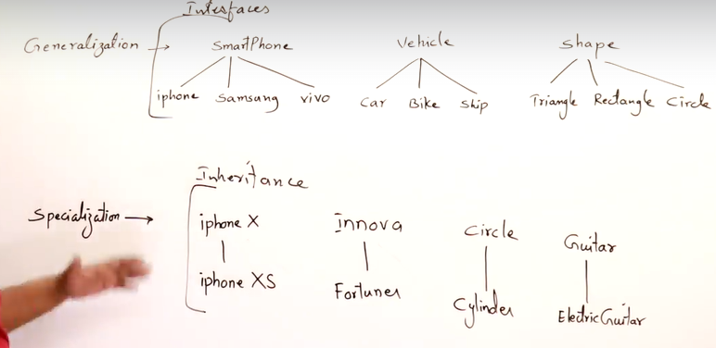

Generalization: You group a object with common properties.

Specialization: You inherit the property from previous and add some net and specialize it. Its derived from super object.

**Inheritance:** Inheritance is the process of acquiring the features of existing class to a new class, i.e.. borrowing the features.

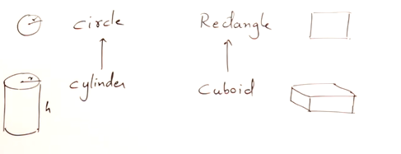

Circle is super class and cylinder is sub class.

Cylinder have all the properties of circle but have an extra properties i.e.. Height.

Cylinder is inherited the properties of circle.

Everything from circle is **available** for cylinder.

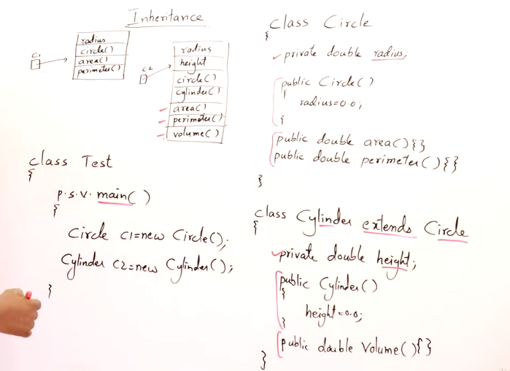

**This Vs Super**

**This :** Wehe you write

Rectangle r1=new Rectangle(10,5); 🡪 A rectangle object is created with values 10,5.

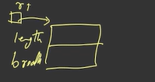 Aconstructor is classes with these parameter.  
Rectangle(int l , int b)🡪 the above thing will be done.

This.length🡪 this is the reference to present or current to object.

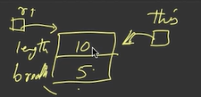

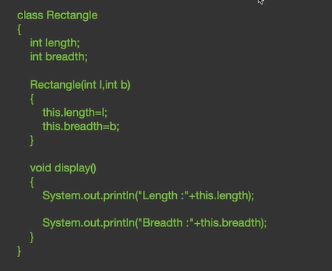

The **this** keyword is used to distinguish between the instance variables and the parameters passed to the constructor. It indicates that we are assigning the values passed as parameters to the instance variables of the current object.  
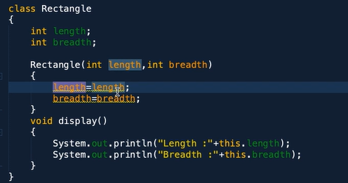🡪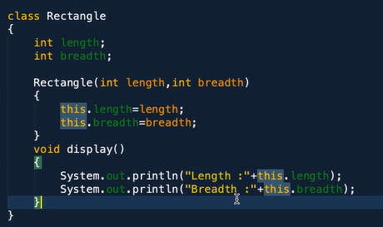

There is name conflict. When we write this it tells that this.length is the property or instance variable.

**‘This’ is a reference to the current object and super is the reference to the super class.**

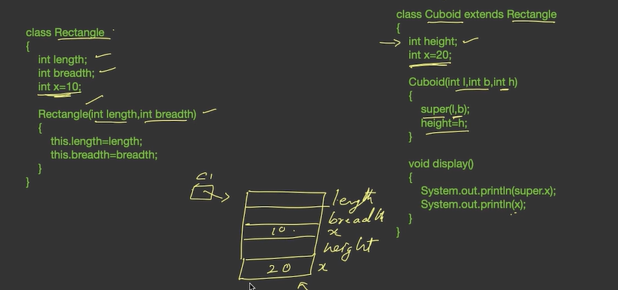

**Method Overriding:**

Redefining a method of super class in sub class.

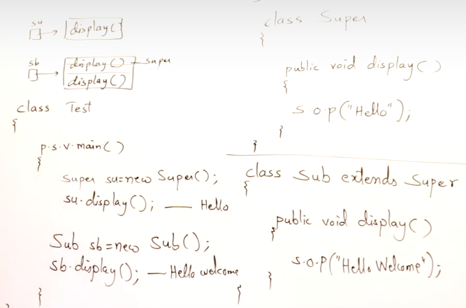

Because they have same name so the super class display method will be shadowed.

You can add @override annotation.

**Dynamic Method Dispatch:**

Object is of sub class and reference of super class. But vice versa not allows.

Super s= new sub(); true

Sub s= new super(); false

Eg: a smart to is also tv but a tft tv is not a smart tv.

Methods are called depending on the object not depending on the reference.

Super class holding and sub class object🡪 overridded method will be called.

Dispatch means calling . dynamic means dynamically clling a method.

**Here's how dynamic method dispatch works in Java:**

1. When a method is invoked on an object, Java looks at the reference type (the type of the variable holding the reference to the object) to determine which method to call.
2. If the method is overridden in the subclass, Java calls the version of the method defined in the subclass, even if the reference type is of the superclass.
3. This enables polymorphic behavior, where objects of different types can respond to the same method invocation in different ways.
4. Dynamic method dispatch allows for flexibility and extensibility in the code, as new subclasses can be added without modifying existing code, and the behavior of the program can be tailored to the specific type of object being operated on.

**Polymorphism:** one name but different actions. Poly means many morphisms means forms.

Polymorphisms is achieved using method overloading and overriding.

New keywords means its object is created at run time.

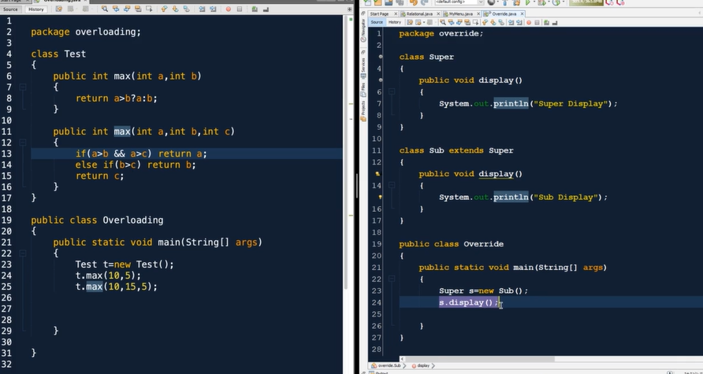

Run-Time Polymorphism or dynamic method dispatcher: achieved through overriding.

Compile-Time Polymorphism: Achieved through method overloading.

Decision is made during compilation.

**Section: 13: Abstract Class**

**Abstract Class:**

* Written with abstract keyword.
* You cannot create the object of abstract class.

Super s1=new super 🡪 not allowed.

* But you can create the reference.

Super s1 🡪 allowed

**Abstract class and Abstract Method:**

* Abstract method: Method doesn’t have body.
* Abstract void method2(); 🡪 and semi colon after method.
* Must be declared as abstract.
* Abstract method means undefined method. When nothing is defined.
* Abstract class is that class that contains zero or more abstract method.
* Abstract class can have zero abstract method by just defining the class as abstract.
* When something is not defined then we can’t create the object.
* When a class is abstract then object.
* If a class inherited from abstract class then the sub class will also be abstract.
* To make that sub class concrete class you must Override the method now the object can be create of sub class.
* Abstract class and method cannot be final.
* Abstract class and method cannot be static.
* Abstract class is useful for polymorphism.

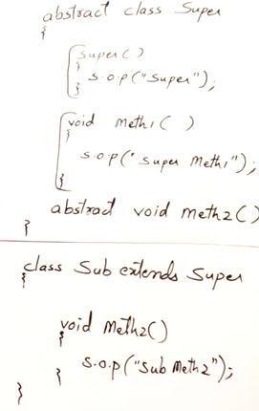

**Why abstract class is need?**

Abstract class is used for defining standard and imposing standards.

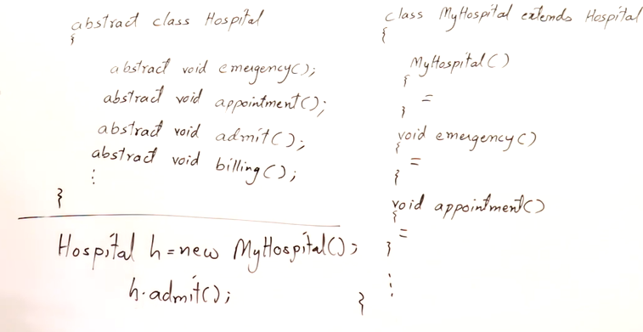

Example: abstract ko dekh kr khali standard mentain kr re hai.

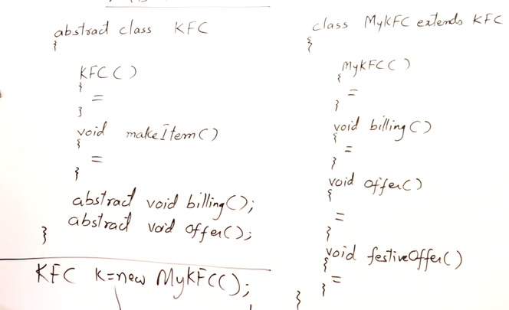

Maine apna frenchisi lia KFC ka lekin usko log KFC hi bolange mtlb ki we are using the reference of KFC.

BILLING is abstraxt bcz billing mera hoga offer mere yaha ka hoga.

Note: all the method are by default abstract and public.

**Section 14: Interfaces**

**Interfaces:**

* Interface is a abstract class with all abstract methods.
* Its is implemented.
* We can achieve polymorphism using interfaces.
* In java a class can extends from only one class, but an interface can implement from more than one class.
* We can have reference of interface but we cannot create object.
* Same hi hota hai abstract class jaisa … standard maintain karne ke lie.
* When a class is implementing a interface it is also a abstract class until you override the method.
* Interface are only meant for achieving override so to achieve run-time polymorphism s so on to dynamic method dispatch.

**Section: 15: Inner Class**

**Inner Class -**

* Class inside a class or nested class.
* To reduce the complexity of bigger classes you can write the inner class.
* Inner class can access the data member or variables of outer class directly.
* You can use inner class by creating its object inside outer class.
* Outer class cannot access the member of inner class directly unless it has created an object.

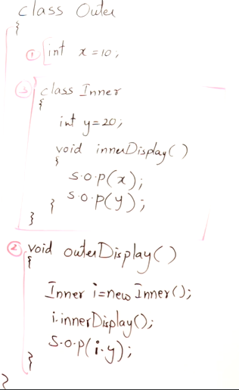

* You can use inner class from outside the outer class by following method.

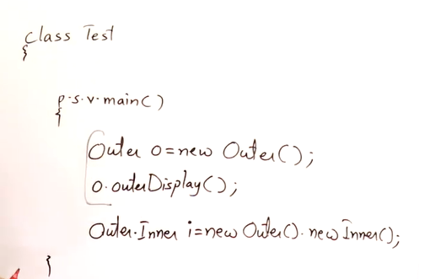

* In Java file is created for every class created.

e.g.: Outer.class

Outer$Inner.class

**Local Inner Class:**

**Anonymous Inner Class**: It is defined at the time of creation of object. Useful in abstract class.

**Section:16: Static and Final**

**Static:** Static member are useful for representing the information about the class.

**Static Keyword:** Is used for representing meta data. (Meta data is data of data).

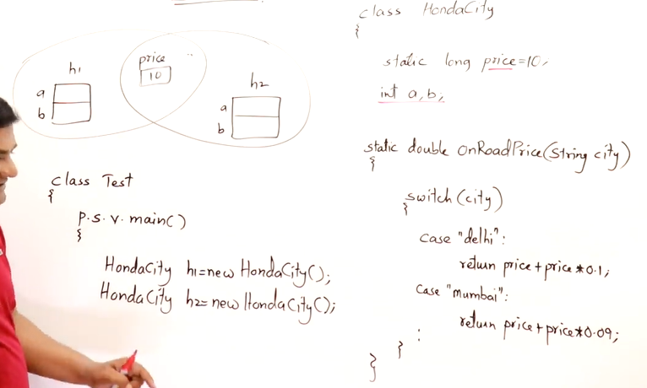

**Static Member** refers to a class(variable or method)that belongs to the class itself, rather than to instance(objects) of the class.

* These members are shared among the instances of the class.
* Jaise kch chize hai jo objects class se hi le lega.
* These are variables declared with the **static** keyword.
* Static variables are initialized only once, at the start of the execution, and are typically used for values that are common to all objects of a class.

**Static Methods:**

* These are methods also declared with the **static** keyword.
* Like static variables, static methods belong to the class rather than to any object.
* They can be called using the class name without the need to instantiate an object of the class.
* Static methods cannot directly access instance variables or instance methods of the class unless they are dealing with a particular instance that is passed to them as an argument.

**Static Block**:

* These are blocks of code enclosed within curly braces **{}** and preceded by the **static** keyword.
* They are executed only once when the class is loaded into memory, typically used for static initialization.
* This is not commonly used.

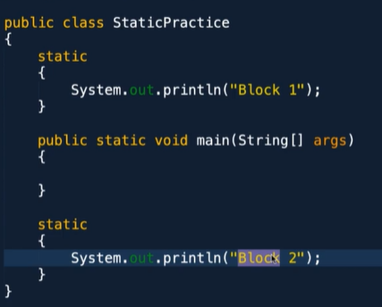🡪 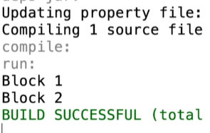

Once we run the program the class get loaded and the things inside the class will be printed.

Static block are always executed first.

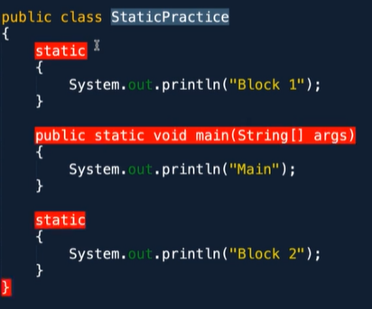🡪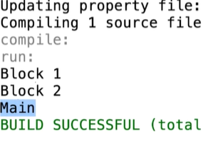

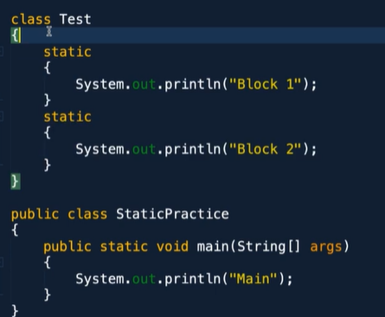🡪 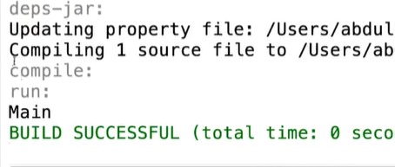

If the class is not used the static will not shown as its not loaded.

*Note: It's important to note that static members are not tied to any particular instance of the class and can be accessed even if no objects of the class have been created.*

**Final:**

* Final Variable are constants, their values are fixed.
* Final is written in capital.
* There are three way to initialize final.
* Direct initialization.
* In static
* In constructor.

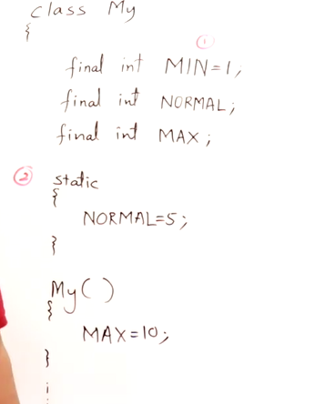

* **final** keyword is used to apply restrictions on classes, methods, and variables.

**Final Variables:**

* When applied to variables, the **final** keyword ensures that the value of the variable cannot be changed once it has been initialized.
* This means you can't reassign a value to a final variable once it's been set.

**Final Methods:**

* When applied to methods, the **final** keyword indicates that the method cannot be overridden by subclasses.
* This is often used to prevent modification of a method's behavior by subclasses.

**Final Classes:**

* When applied to classes, the **final** keyword indicates that the class cannot be subclassed.
* It prevents inheritance and ensures that the class cannot have any subclasses.

**Advantages of Final:**

* Using the **final** keyword provides benefits such as ensuring immutability, preventing method overriding, and prohibiting class inheritance, depending on where it's used.
* It's particularly useful when you want to establish certain elements of your code as unchangeable or non-extendable, thus enhancing code safety and predictability.

**Singleton Class:**

* Singleton is a design pattern that restricts the instantiation of a class to one object.
* This pattern ensures that there is only a single instance of the class and provides a global point of access to that instance.
* The Singleton pattern is commonly used for classes that control access to resources such as database connections, thread pools, and logging facilities.

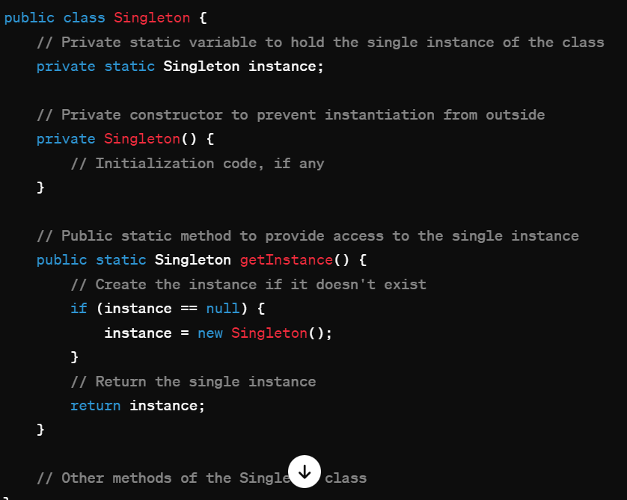

* The class has a private static variable **instance** that holds the single instance of the class.
* The constructor is made private to prevent instantiation of the class from outside.
* The public static method **getInstance()** is provided to get the single instance of the class. This method creates the instance if it doesn't exist and returns the existing instance if it does.

**Access Modifiers:**

* Default
* Private
* Public
* Protected

A class can have three members:

1.Variables

2.Methods

3.Inner class

We can use all the 4-access modifier on all of these class.

But outer class can only be default or public.

There are two methods of using a class.

1. Creating an object of class. 🡪Has a

2. Inheritance i.e.. extending 🡪Is a

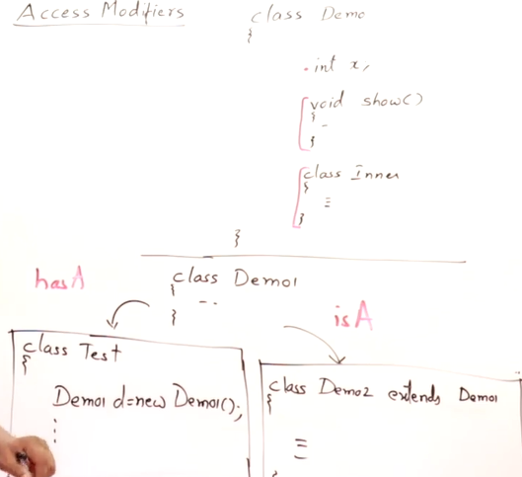

To understand this we have two packages :

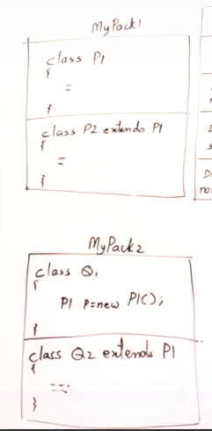

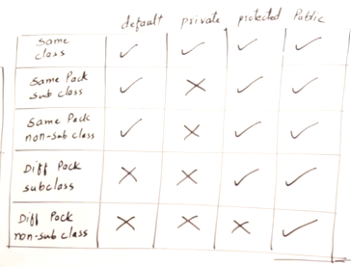

**Access Modifiers:**

* Access modifiers are keywords used to specify the accessibility or visibility of classes, variables, methods, and constructors within a Java program.
* These modifiers control which other classes or packages can access the class, method, variable, or constructor.

**1.Public members:** are accessible from any other class or package. They have the widest scope of accessibility.

**2.Protected members:** are accessible within the same package and also by subclasses (even if they are in different packages).

**3.Default members:** If no access modifier is specified, the default access modifier is applied. Members with default access are accessible only within the same package.

**4.Private members:** Private members are accessible only within the same class. They have the most restricted scope of accessibility.

**Section: 18: Exception Handling**

Exception are runtime errors.

If we have a program there are who people related to a program or application:

1.Programmer.

2.Users.

**Types of Errors:**

**1.Syntax Error:** While typing a program when programs makes a mistake while typing or some syntax is not correct.

e.g: int x,y;

x=10 🡪 so semi colon.

z=x+y; 🡪 z not declared.

These types of error can be removed using compiler. The complier will tell the error.

**2.Logical Error:** Very dangerous error. If a programmer is developing a program but not getting a desired result. Program runs but doesn’t give expected result. These are difficult error to remove, we have to check the program line by line. With the help of debugger and tracer we can remove it.

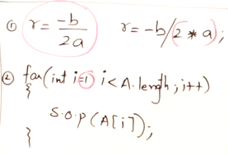

The above two error are faced by programmers.

**3.Runtime Errors:** This faced by user. User cannot do anything in program.

Reason of this error is user in mishandling the program.

e.g.: Age= user give -11.

Program is using internet, but user is not having internet connection.

Program is search for some file, but user has deleted it.

**Problems:**

1.Bad Input

2.Unavailability of Resources

Due to this the program will crash or stop working.

**Solution:**

In case of such error, we can inform the user to properly use the program. Like age should not be negative.

These things should be handled by the programmer so that user should know what he is doing wrong.

So, we follow exception handling.

**How to handle exceptions?**

* As soon as the error/ exception occurs in the program the program halt.
* The programs want the program should not be halted and it should run smoothly.
* If some error occurs the program should tell the user that this is wrong and execute the next line.
* The program should not crash it should terminate smoothly.

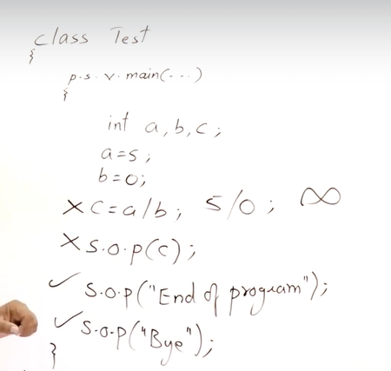

Computer doesn’t know that there is something infinite. So, it treats it as undefined. Any no devide my zero is bad input, this is arithmetic exception.

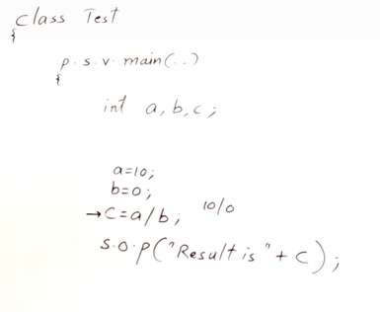🡪 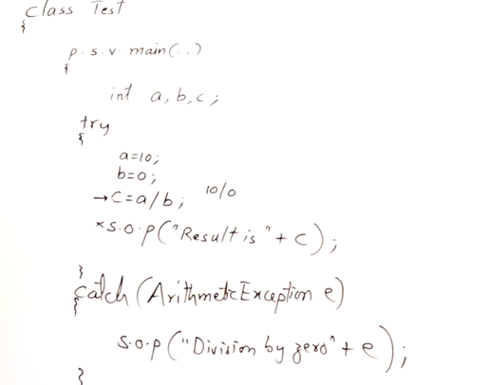

* If there is an exception in, try block then it will enter in catch block. If no error, then it won’t enter.
* There can be multiple catch block for one try block.
* If there in more than one error possible then you can define multiple catch block.

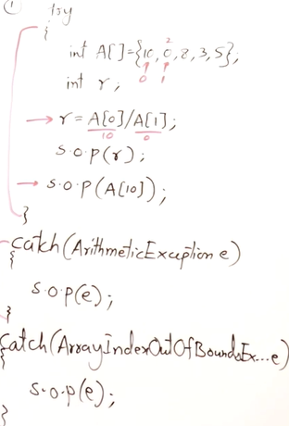

* We can use nested try catch block. i.e., try inside try.

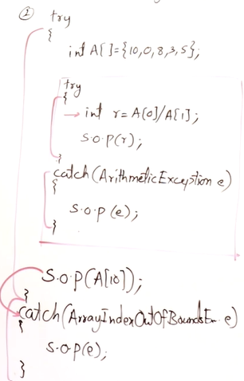

**Finally:** There is a finally block , weather there is exception or not this block will be executes. It a clean-up process.

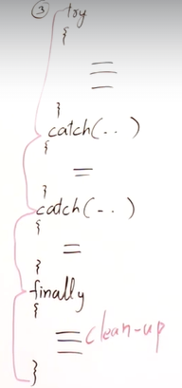

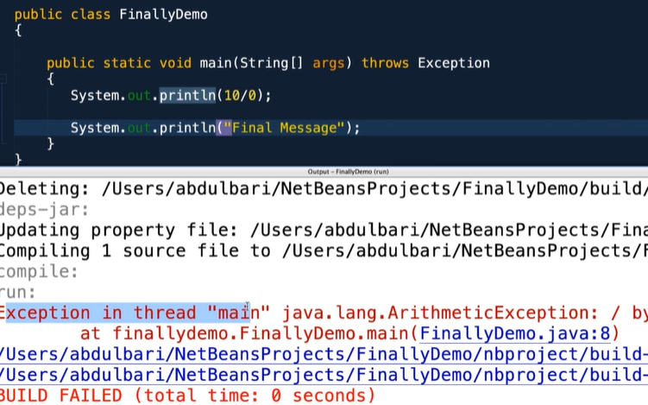

* As soon as the exception occurs the program got crashed and the message is not printed.
* If you want this message to be compulsorily printed, then go for final.
* You can just simply write try and finally block.
* You can write try catch finally all.
* In the below program the exception offered and the program crashed but still the finally block is printed.

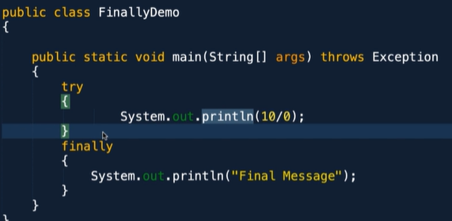 🡪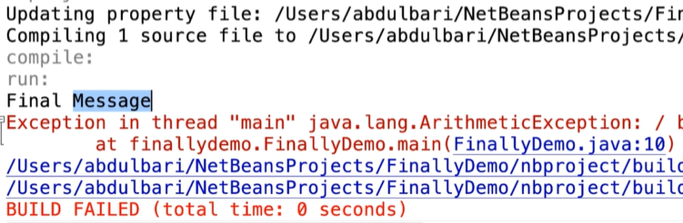

Main Use of finally block is:

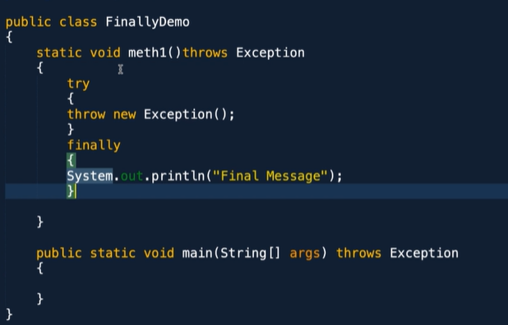

Some key points about the finally block:

* **Execution Guarantee:** The code inside the finally block is guaranteed to execute, regardless of whether an exception occurs or not. This makes it useful for performing cleanup tasks that must occur regardless of exceptional conditions.
* **Usage**: The finally block is typically used to release resources that were acquired in the try block. This includes closing files, database connections, network sockets, etc.
* **No Effect on Exception Handling:** The finally block does not handle exceptions itself. It is simply a way to ensure that certain cleanup operations are performed, regardless of whether an exception is thrown and caught.
* **Order of Execution:** The finally block executes after the try block and any associated catch blocks have completed execution. If an exception is thrown and caught, the finally block still executes before the exception is propagated up the call stack.
* **Return Statements:** If a method contains both a return statement in the try block and a finally block, the finally block will execute before the return statement is executed. However, if the finally block contains a return statement, it will override any previous return statement in the try block.

**Built-in Exception Classes in Java**

Object is the mother class of all the Java classes. From that there is a subclass i.e., throwable.

Exception is the Parent class for all the exceptions.

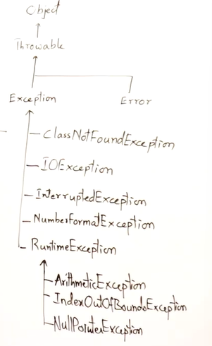

*In the parameter of the catch block there should always be a subclass. Also the subclass should be in the first catch block. Because if you write the patent class first then the next subclass will not work as the parent class already contain that. It will show a syntax error.*

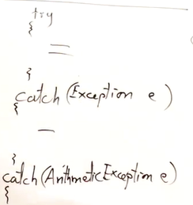*this is wrong…it should be🡪* 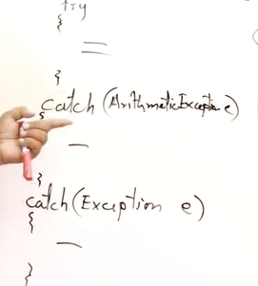

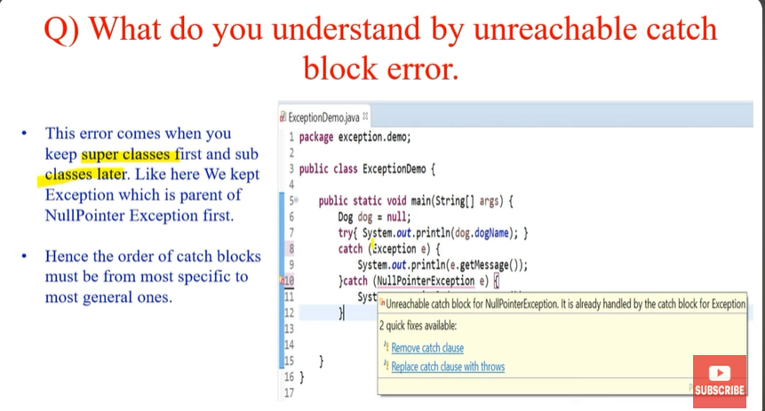

**Exception Class:** It’s a build in class.

* String getMessage()
* String toString()
* Void printStackTrace()

**Checked and Unchecked Exceptions**

**Checked Exceptions: (Compile Time)**

* Checked exceptions are exceptions that are checked at compile-time.
* These exceptions are subclasses of Exception (but not subclasses of RuntimeException or its subclasses).
* The compiler ensures that the code handles checked exceptions, either by catching them using a try-catch block or by declaring that the method throws the checked exception.
* Examples of checked exceptions include IOException, SQLException, ParseException, etc.
* Checked exceptions usually represent external factors that the program cannot control, such as I/O errors, network errors, and data format errors.
* Typically represent external factors beyond the program's control.

**Unchecked Exceptions: (Run time Exception)**

* Unchecked exceptions, also known as runtime exceptions, are exceptions that are not checked at compile-time.
* These exceptions are subclasses of RuntimeException or its subclasses.
* The compiler does not require code to handle or declare unchecked exceptions explicitly.
* Unchecked exceptions often represent programming errors or conditions that should not occur during normal operation.
* Examples of unchecked exceptions include NullPointerException, ArrayIndexOutOfBoundsException, ArithmeticException, etc.

**How is the exception Propagated?**

The exception is raised at method 2🡪 method1🡪 because method 1 has called it🡪main meth()🡪 JVM🡪Program crashes.

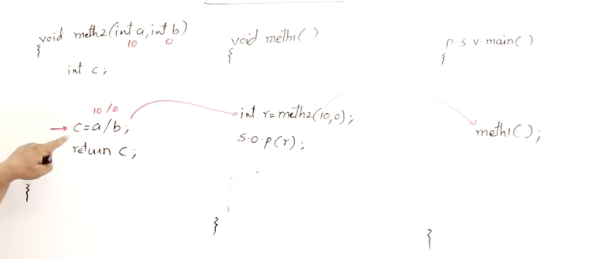

**Look at the below Program**

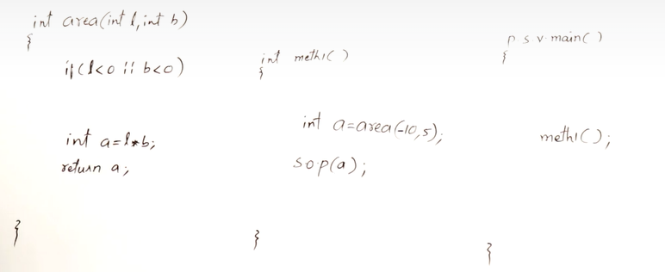

* **Here** in the program area can not be negative so we are checking the condition. But program halts because it cannot do anything and also it cannot return anything.
* (In method area)So we define this exception.
* (In method area)So first we define the condition and then say the compiler that throw this as exception by:
* (In method area)***throw new Exception(“Length negative”);*** *🡪*throw ,new(object of exception) exception Is built in class.
* (To method 2)this will throw the exception to the calling method so you must write try catch block.
* this will throw to calling method so we need to write ***throws Exception*** in front of method. this will show that this method throws exception.
* We can define the try catch block in method 2.
* If you don’t want to catch in method 2.
* Then simply write throws Exception and define the catch block in method1 or main method.
* And if you further want to throw then write throws exception in main and that exception will be passed to JVM and the program will crash.

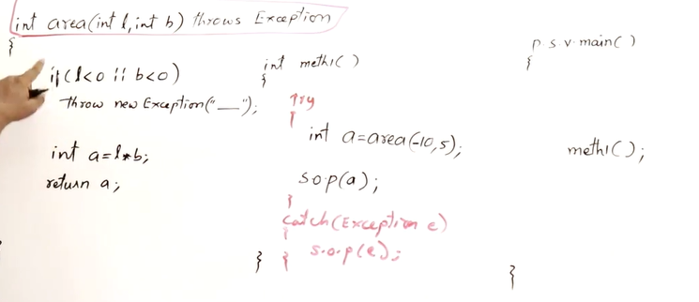

**1.Throws:**

* The throw keyword is used to explicitly throw an exception within a method or block of code.
* When the throw statement is executed, it interrupts the normal flow of the program and transfers control to the nearest enclosing try-catch block or to the method's caller if not caught locally.
* ***if (someCondition) {***

***throw new SomeException("Some error message");***

**2.Throws:**

* The throws keyword is used in method declarations to indicate that the method might throw certain types of exceptions.
* It specifies the exceptions that a method can potentially throw, allowing callers of the method to be aware of the possible exceptions and handle them accordingly.
* Multiple exceptions can be declared using a comma-separated list.
* ***public void someMethod() throws IOException, SQLException***

**3.Throwable:**

* Throwable is the root class for all errors and exceptions in Java.
* It serves as the superclass for both checked exceptions (Exception) and unchecked exceptions (RuntimeException).
* Exceptions and errors are represented as objects of classes that are subclasses of Throwable.
* Throwable provides methods like getMessage(), printStackTrace(), etc., which are commonly used for exception handling and debugging.

***In summary, "throw" is used to raise an exception, "throws" is used in method declarations to specify the exceptions that a method might throw, and "Throwable" is the superclass of all exceptions and errors in Java.***

**User Defined Exception:**

User defined exception must extend from Exception super class in java.

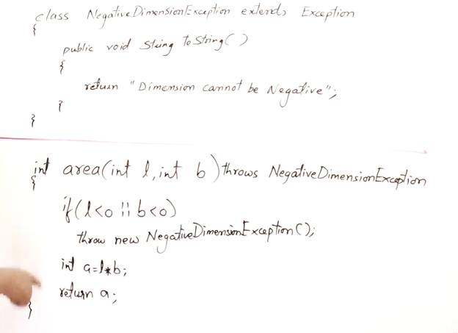

**Try with Resources:**

* All the things outside the program is resources: Heap, Printer, Monitor, Network, etc.
* So ethically whenever you require resources you should take it and once the task is done you should return it.
* It the programs responsibility to release the resource.
* Open the file and close it, print from print, and release the printer.
* Java provide in build heap cleaning system called garbage collector.

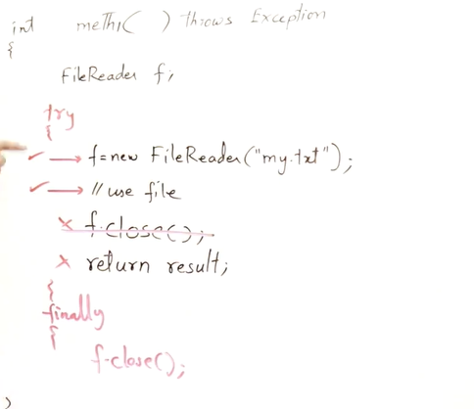

* In the above method if the exception occurs the finally will close the file first(i.e.. release the resource) then throws the exception.
* If exception doesn’t occurs, then finally block will close the file first then it will execute the return statement.
* So, that the resources are freed up.
* NOW   
  **Try with resources**: If you create the resource with try statement the the resource will automatically be released.

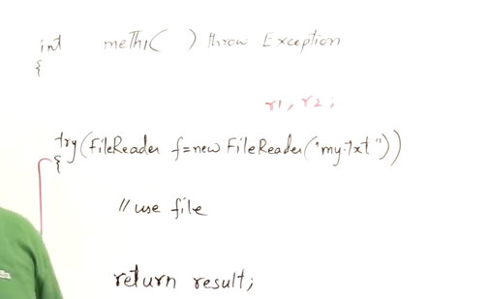  
Try with resources is used to avoid using finally block because here try itself is taking the responsibility of closing the resources.

**Section: 23: Java IO Streams**

**IO Steams:**  Input Output Stream.

Java Program interacts with all the resources by transferring the data.

Keyboard🡪 Input to Java Program  
File🡪Input/Output

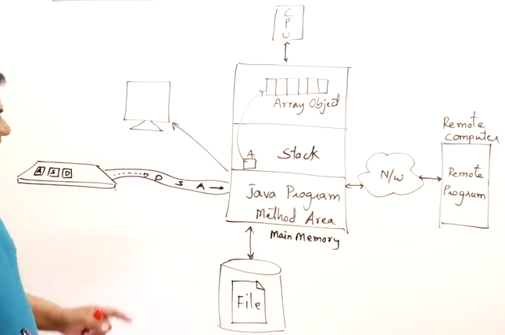

As you go on typing you are sending stream of data (character or bytes).

**Stream:**  Stream is flow of data. Data flow from resource to program or program to resource.

Stream means flow of anything.

**Issues related to Streams:**

**1. Buffer:** Weather the speed at which computer is sending the data and server receiving the data is matching or not.

E.g.: If someone throw ball to you fast and you catching speed is slow then this is problem. You need some buffer.

So, Java programs need buffer. Java program will leave the data in buffer.

Buffer is the memory object for holding the data for some time to bring in the compatibility between the devices. So that all the data is read.

E.g.: Buffering in video.

The rate at which video is play and which is coming from network is different, so the video stops and fill the buffer.

**2.How the data flows in and out?**

Name: “Harsh” is sent to a file. The complete string is not sent at once. It’s broken into bytes and send H🡪 S🡪R🡪A🡪H.

Data flow in term of bytes or character.

Java provide lots of classes in streams.

Java Broadly provides two type of streams:

1. Byte Streams:

* Input Stream
* Output Stream

2. Character Streams:

* Reader
* Writer

**Input and Output Streams Classes:**

**Input Stream Classes:**

* Int read()🡪 reads one byte. It reads one by one. And when the read is over it will return -1.
* Int read(byte[] b)🡪 reads the byte array. It will read the byte according to size.
* Int read(byte[] b, int offset, int length)🡪 fill from specific index and till a length.
* Int available🡪 return the number of byte available in the resource.
* Int skip(long n)🡪discard no of bytes.
* Void mark(int limit)🡪puts a mark on bytes and continue reading. Parameter up to ho many you want to take this mark.
* Void reset()🡪 resets the mark.
* Boolean markSupported()🡪 true false weather stream support mark or not.
* Void close()🡪 after using stream you have to close the stream.

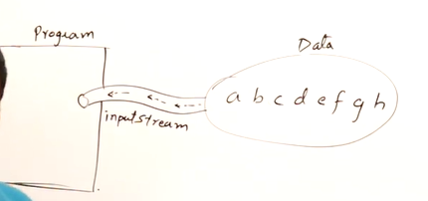

**Output Stream Classes:**

* Void write(int b)🡪 write one byte.
* Void write(byte [] b)🡪 write the byte array.
* Void write(byte[] b, int offset, int length)🡪 write from specific index and till a length.
* Void flush()🡪 only works on buffered string. It will force the data to go out from butter to the resources.
* Voi close()🡪 To close the output stream.

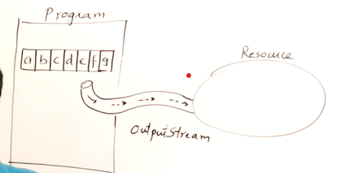

**Streams classes present in Java:**

**Hierarchy:**

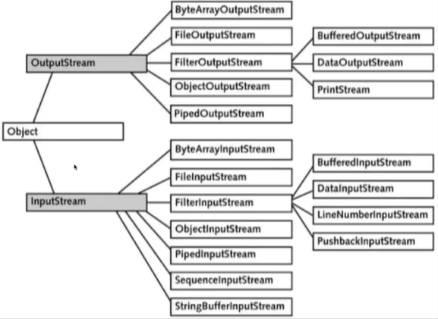

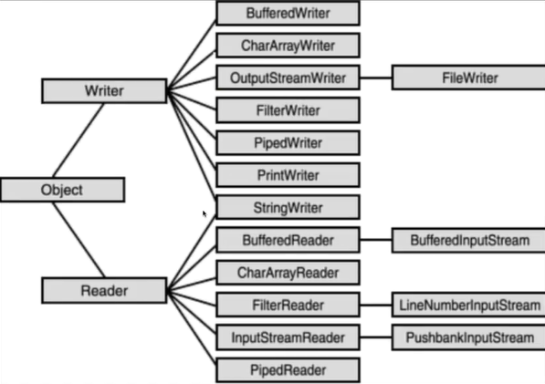

**Exception in IO Streams:**

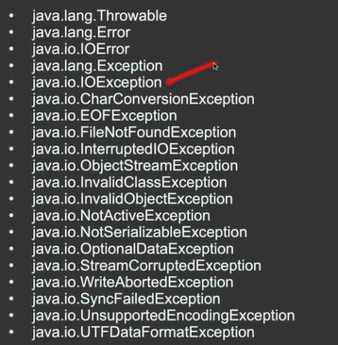

**Section 25: Collection in Java**

**Collection:** Collection framework is nothing but data structure, that is very important to develop applications. The same data structure is built-in provided by Java i.e., Collections.

Let see how Java Program get the data from:

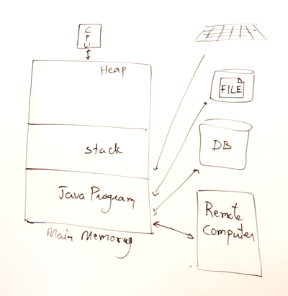

Java will get the collection of values from these sources.

It may be collections:

* Integer values
* Float value
* Students: List of students.
* Books: List of Books.
* Customers: List of customers
* Products and many more.

The Java program will perform the operation on these List.

To process the operation Java Program will hold the data into data structure or collections.

So,

***Collection is arranging the data in the main memory so that it can be used by Java Program.***

Array Has certain limitation.

i.e..

🡪Array has same size or limited size.

If you have requirement to increase or decrease the size of array then you have to create a new array and copy all the elements of previous array into it.

🡪Deletion and Insertion is tough as we have to shift the elements.

Requirement:

1. You can not always decide the size of array.

We want an array which can dynamically change it size.

So, Java provide collections for this kind of problem:

*Collection: Array List and Linked List.*

2. Distinct Collection: No duplicates.

*Collection: Set.*

3. Sorted as well as distinct.

*Collection: SortedSet.*

4. Insertion and Deletion becomes easier on this collection.

5. Searching built-in function are available in collections objects.

*Hashing:* For storing the data in key value which makes easier to search.

**Collection Hierarchy**

**List is order and can have duplicate.**

**Set is unorder and cannot have duplicate.**

**Map is the implements of hashing(key, value) technique.**

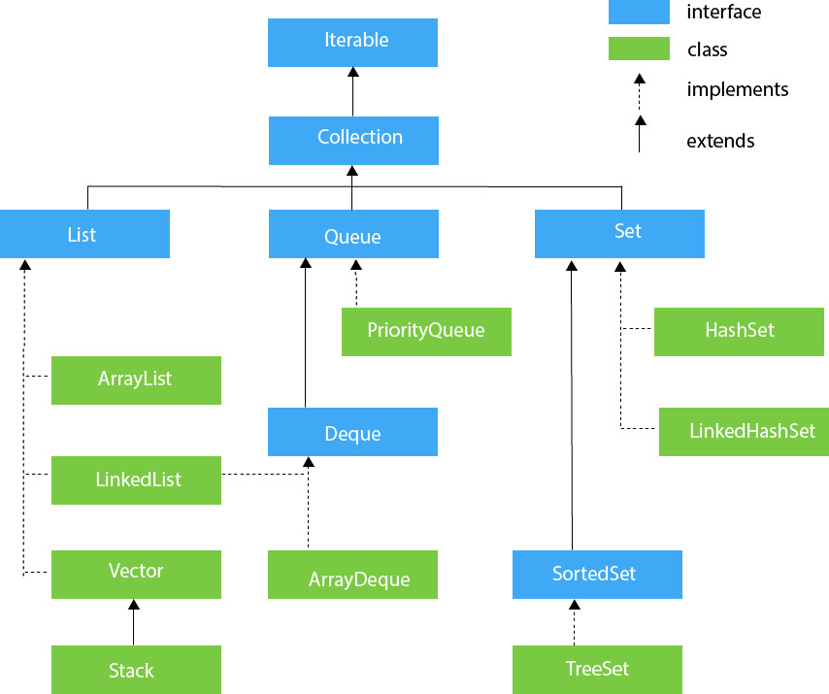

**Methods in Collection Interface**

**Add(E)🡪** Add one object to the collection.

**addall(Collection<E>)🡪** Add all elements from one collection to other. eg: c1.addall(c2).

**remove(object o)🡪** removes that object 🡪 return true of false.

**removeAll(Collection<>)🡪 c1.removeAll(c2)**

**retainAll(Collection)🡪** remove all but retain which are present in c2🡪 c1.retainAll(c2).

**clear()🡪**delete all from collection.

**isEmply()🡪** is the collection empty true-false.

**contains(object)🡪** for one element whether it is present of not 🡪 true-false.

**containsAll(collection<>)🡪** whether all the element are present in the collection or not🡪 true-false

**equals(object o)🡪** compare two collection.

**size()🡪size of collection.**

**iterator()🡪**traversing🡪scanning🡪 visiting all the elements🡪iterating all the elements.-->Only in forward direction.

**toArray()🡪** converts an collection to array.

**Methods in List Interface**

interface List extends Collection.

Whatever is present in collection is also present in List with some additional.

**add(int index, object)🡪** insert an element at a given index.

**addAll(int index, collection<>)🡪** insert collection at a given index.

**remove(int index)🡪** remove an object from given index.

**get(int index)🡪** gives the object at given index.

**set(int index, object)🡪** replace the object at given index.

**subList(int from, int to)🡪** return a sub list which contains the copy of elements from-to.

**indexOf(object)🡪** return the index of given object.(search from left to right)

**lastIndexOf(object**)🡪search from last i.e.. Right to left.

**listIterator()🡪**access the element in any direction.

**listIterator(int index)🡪** access the element in any direction from any index

**Methods in Set Interface.**

Interface set extends from Collection.

It doesn’t have any extra method.

**Methods in Queue Interface**

Interface queue extends from collection.

Whatever is present in collection is also present in Queue with some additional.

**add(object)🡪** add at the end because its FIFO.

**poll()🡪** It will remove first object, if queue empty it will return null.

**remove()🡪** It will remove first object, if queue empty it will throw NOSuchElementException.

**peek()🡪** Given the first object in Queue, if queue empty it will return null.

**element()🡪**Given the first object in Queue, if queue empty it will throw NOSuchElementException.

**Linked List Class of Java**

Java provides LinkedList class which uses doubly linked list.

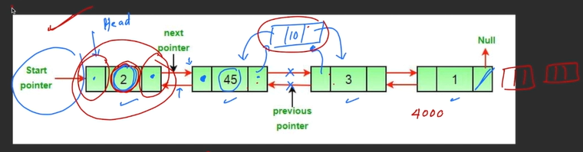

there are no size in linkedlist.

**addFirst(object)🡪** add all starting of linkedlist.

**addLast(object)🡪** add at last of linkedlist.

**getFirst()**

**getLast()**

**ArrayDeque Class of Java:**

Deque means double ended queue. element can inserted and deleted from both side.

This class uses array as data structure.

It can work as a Queue and stack as well.

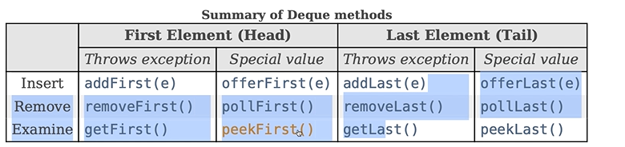

* If it is unable to do the operation it will return null.
* Don’t sue stack instead use deque and.
* Don’t use linkedlist for queue use deque.
* Oracle claims that it is fast.

🡪

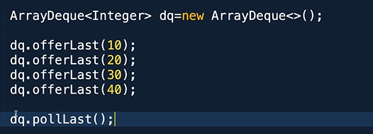🡪inserting from last and deleting from first🡪Stack

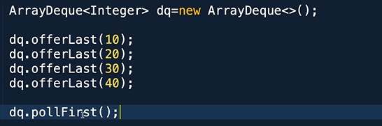🡪 Inserting from last deleting from first🡪 Act like a queue.

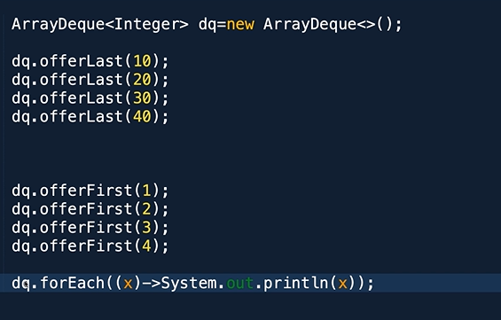

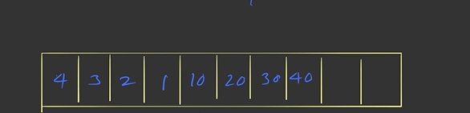

**Priority Queue in Java:**

This represents data structure called Heap.

It is implemented using array.

A priority queue means the elements are inserted or deleted based on priorities.

If an element is small its priority high.

We can not delete a specific element it will delete the highest will be delete.

It is implemented using binary tree.

**Methods Present In Collection Interfaces and all the sub Interfaces.**

The Java Collections Framework defines several interfaces, each with a set of methods that provide common functionality for working with collections. Here are the key methods declared in the core collection interfaces.

**Collection Interface (java.util.Collection):**

* int size(): Returns the number of elements in the collection.
* boolean isEmpty(): Returns true if the collection is empty, false otherwise.
* boolean contains(Object o): Returns true if the collection contains the specified element, false otherwise.
* boolean add(E e): Adds the specified element to the collection and returns true if the collection changed as a result of the call.
* boolean remove(Object o): Removes the specified element from the collection and returns true if the collection contained the element.
* void clear(): Removes all elements from the collection.
* boolean containsAll(Collection<?> c): Returns true if the collection contains all elements in the specified collection.
* boolean addAll(Collection<? extends E> c): Adds all elements in the specified collection to this collection.
* boolean removeAll(Collection<?> c): Removes all elements from this collection that are also in the specified collection.
* boolean retainAll(Collection<?> c): Retains only the elements in this collection that are also in the specified collection.
* Object[] toArray(): Returns an array containing all elements of the collection.
* <T> T[] toArray(T[] a): Returns an array containing all elements of the collection; the runtime type of the returned array is that of the specified array.

**List Interface (java.util.List, extends Collection):**

* E get(int index): Returns the element at the specified index in the list.
* E set(int index, E element): Replaces the element at the specified index in the list with the specified element.
* void add(int index, E element): Inserts the specified element at the specified position in the list.
* E remove(int index): Removes the element at the specified index in the list.

**Set Interface (java.util.Set, extends Collection):**

* No additional methods compared to Collection, but sets enforce uniqueness of elements.

**Map Interface (java.util.Map):**

* int size(): Returns the number of key-value mappings in the map.
* boolean isEmpty(): Returns true if the map contains no key-value mappings, false otherwise.
* boolean containsKey(Object key): Returns true if the map contains a mapping for the specified key, false otherwise.
* boolean containsValue(Object value): Returns true if the map maps one or more keys to the specified value, false otherwise.
* V get(Object key): Returns the value to which the specified key is mapped, or null if the map contains no mapping for the key.
* V put(K key, V value): Associates the specified value with the specified key in the map.
* V remove(Object key): Removes the mapping for the specified key from the map.
* void putAll(Map<? extends K, ? extends V> m): Copies all of the mappings from the specified map to this map.
* void clear(): Removes all mappings from the map.
* Set<K> keySet(): Returns a set view of the keys contained in the map.
* Collection<V> values(): Returns a collection view of the values contained in the map.
* Set<Map.Entry<K, V>> entrySet(): Returns a set view of the mappings contained in the map.

**Queue Interface(java.util.Queue):**

* boolean add(E e): Inserts the specified element into the queue if it is possible to do so immediately without violating capacity restrictions. Throws an exception if the element cannot be added.
* boolean offer(E e): Inserts the specified element into the queue if it is possible to do so immediately without violating capacity restrictions. Returns true if the element was added, false otherwise.
* E remove(): Retrieves and removes the head of the queue. Throws an exception if the queue is empty.
* E poll(): Retrieves and removes the head of the queue, or returns null if the queue is empty.
* E element(): Retrieves, but does not remove, the head of the queue. Throws an exception if the queue is empty.
* E peek(): Retrieves, but does not remove, the head of the queue, or returns null if the queue is empty.
* int size(): Returns the number of elements in the queue.
* boolean isEmpty(): Returns true if the queue contains no elements, false otherwise.
* boolean contains(Object o): Returns true if the queue contains the specified element, false otherwise.
* boolean remove(Object o): Removes the specified element from the queue, if it is present.
* boolean containsAll(Collection<?> c): Returns true if the queue contains all elements in the specified collection, false otherwise.
* boolean removeAll(Collection<?> c): Removes all elements from the queue that are also in the specified collection.
* boolean retainAll(Collection<?> c): Retains only the elements in the queue that are also in the specified collection.

**Section: 19: Multithreading**

**Multiprogramming:** Multiprogramming is running more than one program on single machine.

There are many forms of multiprogramming.

**Multi-User:** More than one user will be using the machine and executing multiple programs simultaneously.

**Multi-Tasking**: Single user will run multiple tasks.

**Multi-Threading:** Single user and multiple tasks inside single application. So, threads are light weighted process. They doesn’t run by processer simultaneously there are executed one by one but that is so fast that user feel like they are running simultaneously.

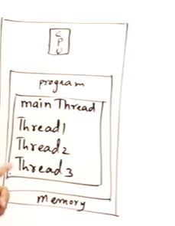 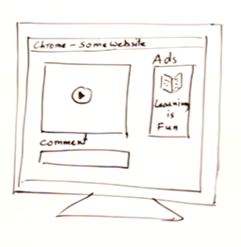

Multiprogramming

/\

/ \

Multiuser Multitasking 🡪 Multithreading.

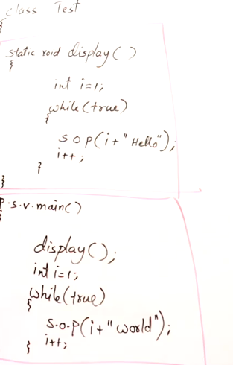

The to things cannot be run simoultaneously.

**How to achieve Multithreading**

**1.Thread class**

**2.Runnable Interface**

**1.Thread Class:**

* The whole mechanism is present here in this thread class.
* Without this you cannot use multithreading.
* Suppose you are writing you own class, and you want multi-threading then say extends thread.

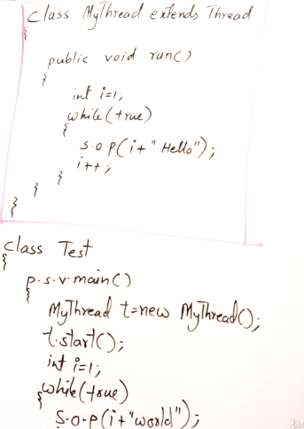 and another way 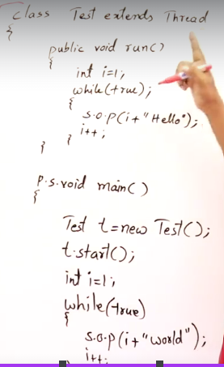

* Here method name is run ().
* Whenever you extends a class from thread class and you want to achieve multi-threading then you must override Run() Method.
* whatever logic you want just write is public void run().
* Run() is the starting point of the thread.
* In main method, create an object of myThread class🡪 Now the thread is created.
* Then we have to class start() method then only we can start the thread.
* Start() is the built-in method in thread class.
* These two things will be running simultaneously.

**2. Runnable Interface:**

* If you want to multi-threading and you are already extending from some class, then say implements runnable.
* Reason, A class can extends from only one class, but an interface can implement more than one class.
* Whenever a class is implementing an interface then it must override all the methods of interface otherwise it will become abstract.

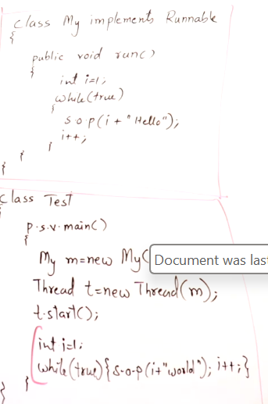another ways 🡪 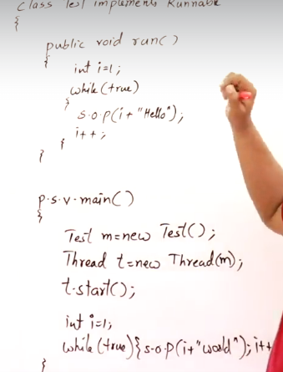

* Here we have created an object of Myclass.
* then we will pass the object of class to the object of created thread class.
* then you have to start the thread by t.start().
* t.start() will execute the run method of the object attached to it.

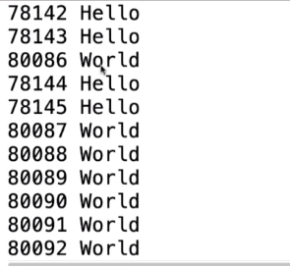 Output of both the programs will be of both the methods as it is switching but the thread and it looks like it working simultaneously.

**States of Thread:**

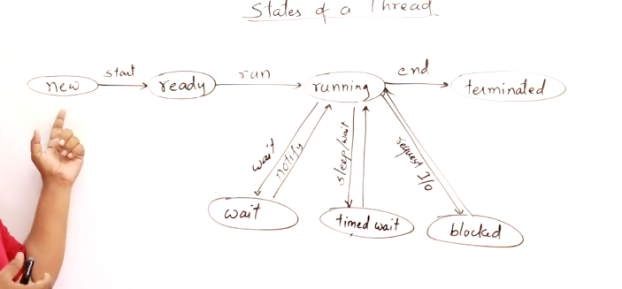 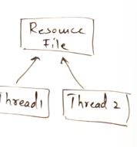

**new:** Create an object of thread it will be in new start.

**ready:** When you call start method it will be in the ready state. Start method internally trigger run method. That is override method.

**running:** Start call run method and it will be in running states.

**terminated:** If a thread has finished its task, it will end and go to terminated state. A thread which is terminated is like a dead thread it can not be started again you have to create new thread.

**wait:** A thread may be waiting for resource; it is in waiting state. once it get notified by other thread it will start.

**timed wait:** When the tread is running you want to delay for some time, you can use sleep () method for sometime then it will be delayed and it will be in timed wait state.

**blocked:** When there are two threads which we want to read a single file, when one thread doesn’t want to access the other thread then it will lock the resource then it will be in a blocked state.

**Note:** Resource should be handled by one thread at a time.

**Thread Priorities:**

Thread can have priorities. Java support priorities.

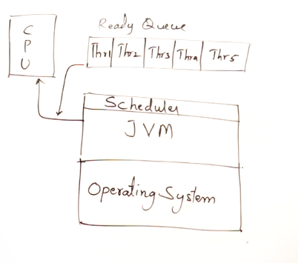

Java support priorities from 1 to 10.

Java doesn’t follow round robin, it follows priorities.

if the thread has higher priority it will be executed first.

JVM have its own scheduler to manage all these.

Thread.MIN_PRIORITY=1

Thread.NORM_PRIORITY=5

Thread.MAX_PRIORITY=10

**Built-in Class Thread:**

There are some commonly used method in thread class.

1. Default Constructor of thread class so that you can create an object.

Thread().

2. Thread(Runnable r): Constructor in which we are passing class which we are using i.e.. runnable interface.

3. Thread(Runnable r, String name): String name is the name of the constructor.

4. Thread(string name): Thread name.

5. Thread(ThreadGroup g, string name): making group of thread so that its easier to use.

**Getxxx() and Setxxx():**

* long getId()🡪 know the id as every thread has a id given by JVM.
* String getName()🡪 name of thread
* int getPriority()🡪 less about the priority.
* Thread.state getState() 🡪tell about the state of thread.
* ThreadGroup getThreadGroup()🡪 Tell about the group.
* void setName()🡪 set name of thread.
* void setPriority() 🡪 Set priority.
* void setDeomon (boolean d)🡪 set as deomon. just pass true or false i.e.. set as deomon or not.

Deomon Thread: is a background thread with least priority.

eg: Garbage collector is a daemon thread.

ms word autosave option.

**Enquiry Method:**

* boolean isAlive()🡪 check weather it is alive or not.
* boolean is Daemon() 🡪 weather it is daemon or not.
* boolean IsInterrupted ()🡪 weather thread is interrupted or not.

**Instance Methods:**

* void interrupt()🡪 thread can be interrupted , it can be stop and moved to waiting or blocked
* void join()🡪 if a thread has finished it job it will get terminated, instead of terminating it can wait for other thread to complete. Using join it can wait for them.
* void join(long millis)🡪 it can join for some time.
* void run()🡪 this override the run method and all the thread mechanism is present here.
* void start()🡪 this is having multithreading method as start the thread i.e execute the run.

**Static Methods:**

Static method can be called by just using class name.

* int activeCount()🡪 tells how many thread are active in a group.
* Thread currentThread()🡪 reference of current running thread.
* void yield ()🡪 applied to thread with higher priority to avoid starvation i.e . it will tell JVM to hold me for some time and give other some chance.

Starvation: Suppose we have multiple thread out of which one thread has highest priority, so it may happen that the thread will hold the CPU for longer time and the other thread will not get the CPU, This is starvation.

* void dumpStack ()🡪 tell the dept of the method call in the stack , sequence of method how the are called.

**Section: Java.Lang Package**

**Object Class:** Object class is the parent class for all the classes in java.

**Wrapper Class:** Java is a object oriented programming, means everything is object.

But in Java primitive(built-in data type) are not object.

if something is object and we put dot then we must get methods, but we don’t get.

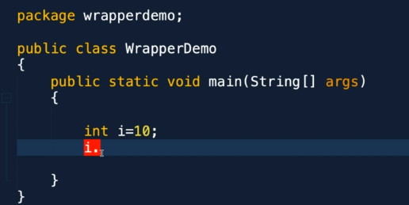

Suppose for primitives also we want class, so that we can treat java as pure object oriented, so java has provided Wrapper classes.

For all data Type java has provided wrapper classes.

All of them are present in Java. Lang package.

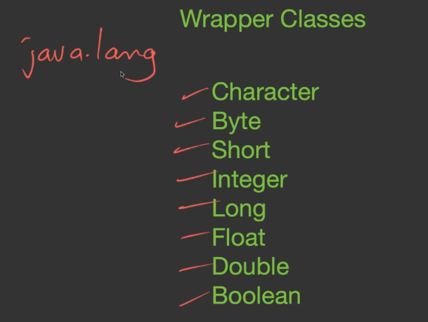 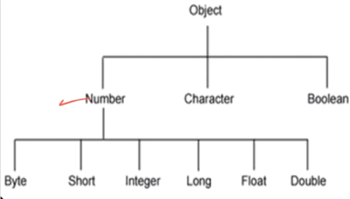

All these are child classes of Number class.

Methods of Number Class.

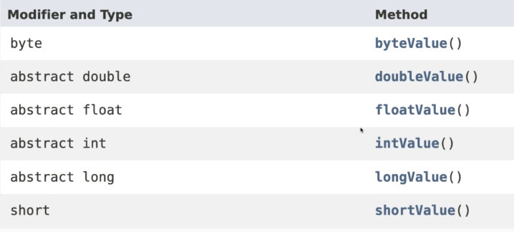

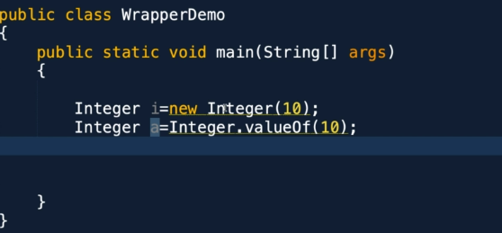

In the above method we are creating an object of integer method and assigning the value.

There two ways of it. passing the value to constructor or by value method.

We can write

Integer i=10;

it internally implement Integer.valueoff.

Then what does is means by wrapper?

wrapper around a primitive so that primitive become an object.

In Java, a wrapper class is a class that encapsulates (wraps) primitive data types into objects. This allows primitive data types to be used as objects in situations where objects are required. Each primitive data type in Java has a corresponding wrapper class.